UNITED STATES
SECURITIES AND EXCHANGE COMMISSION
WASHINGTON, D.C. 20549

FORM 8-K

CURRENT REPORT
Pursuant to Section 13 or 15(d) of the Securities Exchange Act of 1934
Date of Report (Date of earliest event reported): July 27, 2026

Ponce Financial Group, Inc.
(Exact name of Registrant as Specified in Its Charter)

Maryland |  |  | 001-41255 | 87-1893965
(State or Other Jurisdiction  of Incorporation) |  |  | (Commission File Number) | (IRS Employer  Identification No.)
2244 Westchester Avenue
Bronx, New York |  |  |  | 10462
(Address of Principal Executive Offices) |  |  |  | (Zip Code)

Registrant’s Telephone Number, Including Area Code: (718) 931-9000

(Former Name or Former Address, if Changed Since Last Report)

Check the appropriate box below if the Form 8-K filing is intended to simultaneously satisfy the filing obligation of the registrant under any of the following provisions:
☐Written communications pursuant to Rule 425 under the Securities Act (17 CFR 230.425)
☐Soliciting material pursuant to Rule 14a-12 under the Exchange Act (17 CFR 240.14a-12)
☐Pre-commencement communications pursuant to Rule 14d-2(b) under the Exchange Act (17 CFR 240.14d-2(b))
☐Pre-commencement communications pursuant to Rule 13e-4(c) under the Exchange Act (17 CFR 240.13e-4(c))
Securities registered pursuant to Section 12(b) of the Act:
Title of each class |  | Trading  Symbol(s) |  | Name of each exchange on which registered
Common stock, par value $0.01 per share |  | PDLB |  | The Nasdaq Global Market
Indicate by check mark whether the registrant is an emerging growth company as defined in Rule 405 of the Securities Act of 1933 (§ 230.405 of this chapter) or Rule 12b-2 of the Securities Exchange Act of 1934 (§ 240.12b-2 of this chapter).
Emerging growth company ☐
If an emerging growth company, indicate by check mark if the registrant has elected not to use the extended transition period for complying with any new or revised financial accounting standards provided pursuant to Section 13(a) of the Exchange Act. ☐

Item 2.02 Results of Operations and Financial Condition.
On July 27, 2026, Ponce Financial Group, Inc. (the "Company"), the holding company for Ponce Bank, National Association ("Ponce Bank" or the "Bank"), issued a press release announcing its financial results with respect to its second quarter ended June 30, 2026. The Company’s press release is included as Exhibit 99.1 to this report.

The information set forth in this Item 2.02 and in the attached Exhibit 99.1 is deemed to be “furnished” and shall not be deemed to be “filed” for purposes of Section 18 of the Securities Exchange Act of 1934, as amended (the “Exchange Act”), or otherwise subject to the liabilities of that Section.

Item 7.01 Regulation FD Disclosure.

The Company is scheduled to make presentations to current and prospective investors after July 27, 2026. Attached as Exhibit 99.2 of this Form 8-K is a copy of the presentation which Ponce Financial Group, Inc. will make available at these presentations and will post on its website at www.poncebank.com. This report is being furnished to the SEC and shall not be deemed "filed" for any purpose.

Item 9.01 Financial Statements and Exhibits.
(d)Exhibits.
Exhibit Number |  | Description
99.1 |  | Press release dated July 27, 2026
99.2 |  | Presentation of Ponce Financial Group
104 |  | Cover Page Interactive Data File (embedded within the Inline XBRL)

SIGNATURE
Pursuant to the requirements of the Securities Exchange Act of 1934, the registrant has duly caused this report to be signed on its behalf by the undersigned thereunto duly authorized.
 |  |  | Ponce Financial Group, Inc.
Date: | July 27, 2026 | By: | /s/ Carlos P. Naudon
Carlos P. Naudon
President and Chief Executive Officer

Exhibit 99.1
Ponce Financial Group, Inc. Reports Second Quarter 2026 Results

NEW YORK, July 27, 2026 - Ponce Financial Group, Inc., (the “Company”) (Nasdaq: PDLB), the holding company for Ponce Bank, National Association ("Ponce Bank" or the “Bank”), today announced results for the second quarter of 2026.
Second Quarter 2026 Highlights (Compared to Prior Periods):
•
Net income available to common stockholders was $8.2 million, or $0.35 per diluted share for the three months ended June 30, 2026, as compared to net income available to common stockholders of $8.3 million, or $0.36 per diluted share for the three months ended March 31, 2026 and net income available to common stockholders of $5.8 million, or $0.25 per diluted share for the three months ended June 30, 2025. Total net income for the three months ended June 30, 2026 was $8.5 million. The Company paid dividends of $0.3 million on its preferred stock during the three months ended June 30, 2026.
•
Included in the $8.2 million of net income available to common stockholders for the second quarter of 2026 results is $51.7 million in total interest and dividend income and $1.5 million in non-interest income, offset by $21.6 million in interest expense, $18.1 million in non-interest expense, $2.8 million in provision for income taxes, $2.1 million in provision for credit losses and $0.3 million in dividends on preferred shares.
•
Net interest income of $30.1 million for the second quarter of 2026 increased $1.8 million, or 6.50%, from the prior quarter and increased $5.6 million, or 23.07%, from the same quarter last year.
•
Net interest margin was 3.66% for the second quarter of 2026, versus 3.61% for the prior quarter and 3.27% for the same quarter last year.

Six Months 2026 Highlights (Compared to 2025)
•
Net income available to common stockholders was $16.6 million, or $0.71 per diluted share for the six months ended June 30, 2026, as compared to net income available to common stockholders of $11.5 million, or $0.50
per diluted share for the six months ended June 30, 2025. The Company paid dividends of $0.6 million on its preferred stock during each of the six months ended June 30, 2026 and June 30, 2025.
•
Net interest income for the six months ended June 30, 2026 was $58.3 million, an increase of $11.7 million, or 25.0%, compared to $46.6 million for the six months ended June 30, 2025.
•
Non-interest income for six months ended June 30, 2026 was $3.6 million, a decrease of $0.9 million, or 19.6%, from $4.4 million for the six months ended June 30, 2025.
•
Non-interest expense for the six months ended June 30, 2026 was $35.4 million, an increase of $1.6 million, or 4.8%, compared to $33.8 million for the six months ended June 30, 2025.
•
Cash and equivalents were $140.0 million as of June 30, 2026, an increase of $13.9 million, or 10.98%, from $126.2 million as of December 31, 2025.
•
Securities totaled $338.4 million as of June 30, 2026, a decrease of $26.8 million, or 7.34%, from $365.2 million as of December 31, 2025 primarily due to regular principal payments and the maturity of one available-for-sale security in the amount of $3.0 million.
•
Net loans receivable were $2.88 billion as of June 30, 2026, an increase of $280.5 million, or 10.79%, from $2.60 billion as of December 31, 2025.
•
Deposits were $2.27 billion as of June 30, 2026, an increase of $225.2 million, or 11.00%, from $2.05 billion as of December 31, 2025.
President and Chief Executive Officer’s Comments
Carlos P. Naudon, Ponce Financial Group, Inc.’s President and CEO, stated “The consistent execution of our strategy continues to produce strong growth and financial results. Our diluted earnings per share of $0.71 year to date are up 42% versus the same period last year and our book value per share of $13.89 is up $1.55 or 13% over the same period. Net interest margin is up 5 basis points versus last quarter and 39 basis points versus the same quarter last year. Our capital ratios continue to be well in excess of regulatory requirements. We remain committed to the communities we serve, and we’ll continue investing in our people and in technology to improve our efficiency.”
1

Executive Chairman’s Comment

Steven A. Tsavaris, Ponce Financial Group’s Executive Chairman added “We’re pleased with our strong loan and deposit growth this quarter. We’ve filed our 2nd quarter of 2026 QSR (Quarterly Supplemental Report) and believe we have met the necessary lending conditions to repurchase our Preferred Stock under the terms of the ECIP Purchase Option Agreement that we previously entered into with the U.S. Department of the Treasury in late 2024. We are excited about this milestone and the possibilities that the repurchase regulatory process will bring to the Company.”

ECIP
The consummation of any such repurchase of our Preferred Stock is subject to the satisfaction of additional conditions, including satisfying certain eligibility criteria. Although the Company currently expects that it will satisfy all other necessary conditions, there can be no assurance if and when such repurchase will be consummated with Treasury.
The table below indicates the Key Metrics at or for the three months ended:

 | At or for the Three Months Ended
 | June 30, |  |  |  | March 31, |  |  |  | December 31, |  |  |  | September 30, |  |  |  | June 30,
 | 2026 |  |  |  | 2026 |  |  |  | 2025 |  |  |  | 2025 |  |  |  | 2025
Performance Ratios:
Return on average assets (1) |  | 1.00 | % |  |  | 1.07 | % |  |  | 1.26 | % |  |  | 0.82 | % |  |  | 0.79 | %
Return on common equity (1) |  | 9.81 | % |  |  | 10.37 | % |  |  | 12.50 | % |  |  | 8.10 | % |  |  | 7.88 | %
Net interest margin (1) (2) |  | 3.66 | % |  |  | 3.61 | % |  |  | 3.57 | % |  |  | 3.30 | % |  |  | 3.27 | %
Non-interest expense to average assets (1) |  | 2.14 | % |  |  | 2.14 | % |  |  | 2.06 | % |  |  | 2.10 | % |  |  | 2.18 | %
Efficiency ratio (3) |  | 57.41 | % |  |  | 56.96 | % |  |  | 52.95 | % |  |  | 62.15 | % |  |  | 63.69 | %
Capital Ratios:
Total capital to risk-weighted assets (Ponce Financial Group) |  | 20.00 | % |  |  | 21.23 | % |  |  | 23.00 | % |  |  | 24.08 | % |  |  | 22.65 | %
Common equity Tier 1 capital to risk-weighted assets (Ponce Financial Group) |  | 11.51 | % |  |  | 12.11 | % |  |  | 12.98 | % |  |  | 13.39 | % |  |  | 12.49 | %
Tier 1 capital to total assets (Ponce Financial Group) |  | 16.85 | % |  |  | 17.22 | % |  |  | 17.27 | % |  |  | 17.33 | % |  |  | 17.13 | %
Total capital to risk-weighted assets (Bank only) |  | 18.88 | % |  |  | 20.00 | % |  |  | 21.63 | % |  |  | 21.79 | % |  |  | 21.22 | %
Common equity Tier 1 capital to risk-weighted assets (Bank only) |  | 17.87 | % |  |  | 18.97 | % |  |  | 20.53 | % |  |  | 20.66 | % |  |  | 20.15 | %
Tier 1 capital to total assets (Bank only) |  | 15.81 | % |  |  | 16.09 | % |  |  | 16.12 | % |  |  | 16.08 | % |  |  | 15.99 | %
Asset Quality Ratios:
Allowance for credit losses on loans as a percentage of total loans |  | 0.95 | % |  |  | 0.96 | % |  |  | 0.97 | % |  |  | 0.98 | % |  |  | 0.97 | %
Allowance for credit losses on loans as a percentage of nonperforming loans |  | 116.91 | % |  |  | 128.93 | % |  |  | 94.74 | % |  |  | 88.88 | % |  |  | 101.01 | %
Net (charge-offs) recoveries to average outstanding loans (1) |  | (0.05 | %) |  |  | (0.08 | %) |  |  | (0.13 | %) |  |  | (0.03 | %) |  |  | (0.04 | %)
Non-performing loans as a percentage of total assets |  | 0.67 | % |  |  | 0.62 | % |  |  | 0.83 | % |  |  | 0.88 | % |  |  | 0.76 | %
Other:
Number of offices |  | 17 |  |  |  | 17 |  |  |  | 17 |  |  |  | 18 |  |  |  | 17
Number of full-time equivalent employees |  | 229 |  |  |  | 218 |  |  |  | 216 |  |  |  | 209 |  |  |  | 206

(1)
Annualized.
(2)
Net interest margin represents net interest income divided by average total interest-earning assets.
(3)
Efficiency ratio represents noninterest expense divided by the sum of net interest income and noninterest income.

2

Summary of Results of Operations

Net income for the three months ended June 30, 2026 was $8.5 million compared to net income of $8.6 million for the three months ended March 31, 2026 and net income of $6.1 million for the three months ended June 30, 2025.

The $0.1 million decrease of net income for the three months ended June 30, 2026 compared to the three months ended March 31, 2026 was attributed mainly to an increase of $0.9 million non-interest expense, a decrease of $0.5 million in non-interest income and an increase of $0.5 million in provision for credit losses, offset by an increase of $1.8 million in net interest income.
The $2.4 million increase of net income for the three months ended June 30, 2026 compared to the three months ended June 30, 2025 was largely due to an increase of $5.6 million in net interest income, offset by increases of $1.3 million in non-interest expense, $0.9 million in provision for income taxes and $0.5 million in provision for credit losses and a decrease of $0.5 million in non-interest income recognized in the second quarter of 2025.

Net income for the six months ended June 30, 2026 was $17.1 million compared to net income of $12.1 million for the six months ended June 30, 2025. The $5.1 million increase in net income was attributed mainly to an increase of $11.7 million in net interest income, offset by increases of $2.5 million in provision for credit losses, $1.6 million in non-interest expense, $1.6 million in provision for income taxes and a decrease of $0.9 million in non-interest income.

Net Interest Income and Net Interest Margin

Net interest income for the three months ended June 30, 2026, increased $1.8 million, or 6.50%, to $30.1 million compared to $28.2 million for the three months ended March 31, 2026 and increased $5.6 million, or 23.07%, compared to $24.4 million for the three months ended June 30, 2025.

The $1.8 million increase in net interest income from the three months ended March 31, 2026 was attributable to an increase of $3.0 million in total interest and dividend income, offset by an increase of $1.2 million in total interest expense. The $5.6 million increase in net interest income from the three months ended June 30, 2025 was attributable to an increase of $5.8 million in total interest and dividend income, offset by an increase of $0.2 million in total interest expense.

Net interest income for the six months ended June 30, 2026, increased $11.7 million, or 25.00%, to $58.3 million compared to $46.6 million for the six months ended June 30, 2025. The $11.7 million increase in net interest income from the six months ended June 30, 2025 was attributable to an increase of $10.5 million in total interest and dividend income and a decrease of $1.2 million in total interest expense.

Net interest margin was 3.66% for the three months ended June 30, 2026 compared to 3.61% for the prior quarter, an increase of 5bps and 3.27% for the same period last year, an increase of 39bps.

Net interest margin was 3.64% for the six months ended June 30, 2026 compared to 3.12% for the six months ended June 30, 2025, an increase of 52bps.

Non-interest Income

Non-interest income for the three months ended June 30, 2026, was $1.5 million, a decrease of $0.5 million, or 25.22%, compared to $2.0 million for the three months ended March 31, 2026, and a decrease of $0.5 million, or 25.87%, compared to the three months ended June 30, 2025.
The $0.5 million decrease in non-interest income from the three months ended March 31, 2026 was largely attributable to a decrease of $0.6 million in late and prepayment charges.

The $0.5 million decrease in non-interest income from the three months ended June 30, 2025 was largely attributable to decreases of $0.4 million in late and prepayment charges and $0.4 million in grant income recognized in the second quarter of 2025, offset by an increase of $0.2 million in other non-interest income.

3

Non-interest income for the six months ended June 30, 2026, was $3.6 million, a decrease of $0.9 million, or 19.64%, compared to $4.4 million for the six months ended June 30, 2025. The $0.9 million decrease in non-interest income from the six months ended June 30, 2025 was largely attributable to decreases of $0.4 million in late and prepayment charges, $0.4 million in income on sale of SBA loans and $0.4 million in grant income recognized in the second quarter of 2025, offset by increases on $0.3 million in other non-interest income and $0.1 million in service charges and fees.

Non-interest Expense

Non-interest expense for the three months ended June 30, 2026 was $18.1 million, an increase of $0.9 million, or 5.19%, compared to $17.2 million for the three months ended March 31, 2026 and an increase of $1.3 million, or 7.50%, compared to $16.9 million for the three months ended June 30, 2025.

The $0.9 million increase in non-interest expense from the three months ended March 31, 2026 was mainly attributable to increases of $0.4 million in compensation and benefits, $0.2 million in occupancy and equipment, $0.2 million in other non-interest expenses and $0.1 million in professional fees.

The $1.3 million increase in non-interest expense from the three months ended June 30, 2025 was mainly attributable to an increase of $1.4 million in compensation and benefits, partially offset by a decrease of $0.1 million in federal deposit insurance and regulatory assessment.

Non-interest expense for the six months ended June 30, 2026 was $35.4 million, an increase of $1.6 million, or 4.79%, compared to $33.8 million for the six months ended June 30, 2025. The $1.6 million increase in non-interest expense from the six months ended June 30, 2025 was mainly attributable to an increase of $2.3 million in compensation and benefits, partially offset by decreases of $0.3 million in direct loan expenses, $0.2 million in occupancy and equipment, $0.2 million in other non-interest expenses and $0.2 million in federal deposit insurance and regulatory assessment.

Credit Quality:

Total non-performing assets and accruing modifications to borrowers experiencing financial difficulty were $26.8 million at June 30, 2026 compared to $23.6 million at March 31, 2026 and $28.5 million at June 30, 2025.

During the three months ended June 30, 2026, a credit loss provision of $2.1 million on loans was recorded, consisting of $1.7 million charged on the funded portion and $0.4 million charged on the unfunded portion on loans. During the three months ended March 31, 2026, a credit loss provision of $1.7 million on loans was recorded, consisting of $1.3 million charged on the funded portion and $0.4 million charged on the unfunded portion on loans. During the three months ended June 30, 2025, a credit loss provision of $1.6 million on loans was recorded, consisting of $1.3 million charged on the funded portion on loans and $0.3 million charged on the unfunded portion on loans.

During the six months ended June 30, 2026, a credit loss provision of $3.8 million on loans was recorded, consisting of $3.0 million charged on the funded portion and $0.8 million charged on the unfunded portion on loans. During the six months ended June 30, 2025, a credit loss provision of $1.3 million on loans was recorded, consisting of $2.0 million charged on the funded portion on loans and a $0.7 million benefit on the unfunded portion on loans.

Balance Sheet Summary

Total assets increased $270.7 million, or 8.40%, to $3.49 billion as of June 30, 2026 from $3.22 billion as of December 31, 2025. The increase in total assets is largely attributable to increases of $280.5 million in net loans receivable, $13.9 million in cash and cash equivalents, $2.0 million in accrued interest receivable, $1.5 million in deferred tax assets, $1.4 million in Federal Home Loan Bank of New York stock and $0.1 million in other assets, partially offset by decreases of $19.4 million in held-to-maturity securities, $7.4 million in available-for-sale securities, $1.0 million in premises and equipment, net, $0.5 million in right of use assets and $0.3 million in mortgage loans held for sale, at fair value.

Total liabilities increased $251.3 million, or 9.37%, to $2.93 billion as of June 30, 2026 from $2.68 billion as of December 31, 2025. The increase in total liabilities was largely attributable to increases of $225.2 million in deposits, $25.0 million in borrowings and $1.6 million in other liabilities, partially offset by a decrease of $0.5 million in operating lease liabilities.
4

Total stockholders’ equity increased $19.4 million, or 3.59%, to $561.0 million as of June 30, 2026, from $541.5 million as of December 31, 2025. The $19.4 million increase in stockholders’ equity was largely attributable to $17.1 million in net income, $0.2 million from exercise of stock options, $1.3 million impact to additional paid in capital as a result of share-based compensation, $1.2 million from release of ESOP shares, and $0.1 million in other comprehensive income, offset by $0.6 million related to the dividend paid on preferred shares during the six months ended June 30, 2026.

About Ponce Financial Group, Inc.
Ponce Financial Group, Inc. is the holding company for Ponce Bank, N.A. Ponce Bank, N.A. is a Minority Depository Institution, a Community Development Financial Institution, and a certified Small Business Administration lender. Ponce Bank, N.A.’s business primarily consists of taking deposits from the general public and to a lesser extent alternative funding sources and investing those funds, together with funds generated from operations and borrowings, in mortgage loans, consisting of 1-4 family residences (investor-owned and owner-occupied), multifamily residences, nonresidential properties, construction and land, and, to a lesser extent, in business and consumer loans. Ponce Bank. N.A. also invests in securities, which consist of U.S. Government and federal agency securities and securities issued by government-sponsored or government-owned enterprises, as well as, mortgage-backed securities, corporate bonds and obligations, Federal Home Loan Bank stock and Federal Reserve Bank stock.
Forward Looking Statements
Certain statements herein constitute forward-looking statements within the meaning of Section 27A of the Securities Act of 1933, as amended, and Section 21E of the Exchange Act and are intended to be covered by the safe harbor provisions of the Private Securities Litigation Reform Act of 1995. Such statements may be identified by words such as “believes,” “will,” “would,” “expects,” “project,” “may,” “could,” “developments,” “strategic,” “launching,” “opportunities,” “anticipates,” “estimates,” “intends,” “plans,” “targets” and similar expressions. These statements are based upon the current beliefs and expectations of management and are subject to significant risks and uncertainties. Actual results may differ materially from those set forth in the forward-looking statements as a result of numerous factors. Factors that could cause such differences to exist include, but are not limited to, adverse conditions in the capital and debt markets and the impact of such conditions on business activities; changes in interest rates; competitive pressures from other financial institutions; the effects of general economic conditions on a national basis or in the local markets in which Ponce Bank, N.A. operates, including changes that adversely affect borrowers’ ability to service and repay Ponce Bank, N.A.’s loans; changes in U.S. trade policies, including the imposition of tariffs and retaliatory tariffs, and their related impacts on the economy; changes in the global economy, including negative changes that may arise from armed conflict and geopolitical instability; changes in the value of securities in the investment portfolio; changes in loan default and charge-off rates; fluctuations in real estate values; the adequacy of loan loss reserves; decreases in deposit levels necessitating increased borrowing to fund loans and investments; operational risks including, but not limited to, cybersecurity, fraud and natural disasters; changes in government regulation; changes in accounting standards and practices; the risk that intangibles recorded in the financial statements will become impaired; demand for loans in Ponce Bank, N.A.’s market area; Ponce Bank, N.A.’s ability to attract and maintain deposits; risks related to the implementation of acquisitions, dispositions, and restructurings; the risk that Ponce Financial Group, Inc. may not be successful in the implementation of its business strategy; changes in assumptions used in making such forward-looking statements and the risk factors described in Ponce Financial Group, Inc.’s Annual Report on Form 10-K and Quarterly Reports on Form 10-Q as filed with the Securities and Exchange Commission (the “SEC”), which are available at the SEC’s website, www.sec.gov. Readers are cautioned not to place undue reliance on these forward-looking statements, which speak only as of the date of this release. Ponce Financial Group, Inc. disclaims any obligation to publicly update or revise any forward-looking statements to reflect changes in underlying assumptions or factors, new information, future events or other changes, except as may be required by applicable law or regulation.
5

Ponce Financial Group, Inc. and Subsidiaries
Consolidated Statements of Financial Condition
(Dollars in thousands, except for share data)

 | As of
 | June 30, |  |  |  | March 31, |  |  |  | December 31, |  |  |  | September 30, |  |  |  | June 30,
 | 2026 |  |  |  | 2026 |  |  |  | 2025 |  |  |  | 2025 |  |  |  | 2025
ASSETS
Cash and due from banks:
Cash | $ | 25,567 |  |  | $ | 27,429 |  |  | $ | 28,511 |  |  | $ | 29,296 |  |  | $ | 35,767
Interest-bearing deposits |  | 114,443 |  |  |  | 89,817 |  |  |  | 97,643 |  |  |  | 117,283 |  |  |  | 90,872
Total cash and cash equivalents |  | 140,010 |  |  |  | 117,246 |  |  |  | 126,154 |  |  |  | 146,579 |  |  |  | 126,639
Available-for-sale securities, at fair value |  | 84,774 |  |  |  | 87,150 |  |  |  | 92,196 |  |  |  | 94,822 |  |  |  | 96,562
Held-to-maturity securities, at amortized cost |  | 253,616 |  |  |  | 263,514 |  |  |  | 272,982 |  |  |  | 285,125 |  |  |  | 336,879
Placement with banks |  | 249 |  |  |  | 249 |  |  |  | 249 |  |  |  | 249 |  |  |  | 249
Mortgage loans held for sale, at fair value |  | 3,050 |  |  |  | 2,127 |  |  |  | 3,388 |  |  |  | 5,794 |  |  |  | 5,703
Loans receivable, net |  | 2,879,740 |  |  |  | 2,698,649 |  |  |  | 2,599,258 |  |  |  | 2,490,046 |  |  |  | 2,458,712
Accrued interest receivable |  | 19,939 |  |  |  | 19,274 |  |  |  | 17,905 |  |  |  | 18,903 |  |  |  | 19,126
Premises and equipment, net |  | 14,645 |  |  |  | 15,159 |  |  |  | 15,638 |  |  |  | 16,129 |  |  |  | 16,067
Right of use assets |  | 27,055 |  |  |  | 27,633 |  |  |  | 27,583 |  |  |  | 28,295 |  |  |  | 28,806
Federal Home Loan Bank of New York stock (FHLBNY), at cost |  | 30,689 |  |  |  | 28,180 |  |  |  | 29,309 |  |  |  | 25,945 |  |  |  | 26,620
Federal Reserve Bank of New York stock (FRBNY), at cost |  | 10,714 |  |  |  | 10,706 |  |  |  | 10,698 |  |  |  | — |  |  |  | —
Deferred tax assets |  | 12,979 |  |  |  | 11,729 |  |  |  | 11,501 |  |  |  | 12,402 |  |  |  | 12,143
Other assets |  | 17,251 |  |  |  | 19,141 |  |  |  | 17,109 |  |  |  | 32,790 |  |  |  | 26,363
Total assets | $ | 3,494,711 |  |  | $ | 3,300,757 |  |  | $ | 3,223,970 |  |  | $ | 3,157,079 |  |  | $ | 3,153,869
LIABILITIES AND STOCKHOLDERS' EQUITY
Liabilities:
Deposits | $ | 2,271,809 |  |  | $ | 2,133,795 |  |  | $ | 2,046,635 |  |  | $ | 2,063,081 |  |  | $ | 2,053,151
Borrowings |  | 621,100 |  |  |  | 571,100 |  |  |  | 596,100 |  |  |  | 521,100 |  |  |  | 536,100
Operating lease liabilities |  | 28,874 |  |  |  | 29,429 |  |  |  | 29,353 |  |  |  | 30,028 |  |  |  | 30,501
Accrued interest payable |  | 3,837 |  |  |  | 4,338 |  |  |  | 3,788 |  |  |  | 4,372 |  |  |  | 4,161
Other liabilities |  | 8,121 |  |  |  | 10,732 |  |  |  | 6,545 |  |  |  | 8,663 |  |  |  | 8,868
Total liabilities |  | 2,933,741 |  |  |  | 2,749,394 |  |  |  | 2,682,421 |  |  |  | 2,627,244 |  |  |  | 2,632,781
Commitments and contingencies
Stockholders' Equity:
Preferred stock, $0.01 par value; 100,000,000 shares authorized |  | 225,000 |  |  |  | 225,000 |  |  |  | 225,000 |  |  |  | 225,000 |  |  |  | 225,000
Common stock, $0.01 par value; 200,000,000 shares authorized |  | 249 |  |  |  | 249 |  |  |  | 249 |  |  |  | 249 |  |  |  | 249
Treasury stock, at cost |  | (5,738 | ) |  |  | (5,738 | ) |  |  | (6,164 | ) |  |  | (7,270 | ) |  |  | (7,404 | )
Additional paid-in-capital |  | 210,339 |  |  |  | 209,219 |  |  |  | 208,604 |  |  |  | 208,909 |  |  |  | 208,275
Retained earnings |  | 151,887 |  |  |  | 143,674 |  |  |  | 135,332 |  |  |  | 125,477 |  |  |  | 119,250
Accumulated other comprehensive loss |  | (10,698 | ) |  |  | (10,680 | ) |  |  | (10,820 | ) |  |  | (11,586 | ) |  |  | (13,047 | )
Unearned compensation ─ ESOP |  | (10,069 | ) |  |  | (10,361 | ) |  |  | (10,652 | ) |  |  | (10,944 | ) |  |  | (11,235 | )
Total stockholders' equity |  | 560,970 |  |  |  | 551,363 |  |  |  | 541,549 |  |  |  | 529,835 |  |  |  | 521,088
Total liabilities and stockholders' equity | $ | 3,494,711 |  |  | $ | 3,300,757 |  |  | $ | 3,223,970 |  |  | $ | 3,157,079 |  |  | $ | 3,153,869

6

Ponce Financial Group, Inc. and Subsidiaries
Consolidated Statements of Operations
(Dollars in thousands, except per share data)

 | Three Months Ended
 | June 30, |  |  |  | March 31, |  |  |  | December 31, |  |  |  | September 30, |  |  |  | June 30,
 | 2026 |  |  |  | 2026 |  |  |  | 2025 |  |  |  | 2025 |  |  |  | 2025
Interest and dividend income:
Interest on loans receivable | $ | 46,835 |  |  | $ | 43,982 |  |  | $ | 43,599 |  |  | $ | 41,486 |  |  | $ | 40,291
Interest on deposits due from banks |  | 954 |  |  |  | 770 |  |  |  | 1,209 |  |  |  | 978 |  |  |  | 807
Interest and dividend on securities and FHLBNY stock |  | 3,863 |  |  |  | 3,910 |  |  |  | 4,013 |  |  |  | 4,383 |  |  |  | 4,762
Total interest and dividend income |  | 51,652 |  |  |  | 48,662 |  |  |  | 48,821 |  |  |  | 46,847 |  |  |  | 45,860
Interest expense:
Interest on certificates of deposit |  | 6,785 |  |  |  | 6,415 |  |  |  | 6,706 |  |  |  | 6,553 |  |  |  | 7,382
Interest on other deposits |  | 9,544 |  |  |  | 8,630 |  |  |  | 9,106 |  |  |  | 9,996 |  |  |  | 9,058
Interest on borrowings |  | 5,262 |  |  |  | 5,391 |  |  |  | 5,075 |  |  |  | 5,050 |  |  |  | 4,994
Total interest expense |  | 21,591 |  |  |  | 20,436 |  |  |  | 20,887 |  |  |  | 21,599 |  |  |  | 21,434
Net interest income |  | 30,061 |  |  |  | 28,226 |  |  |  | 27,934 |  |  |  | 25,248 |  |  |  | 24,426
Provision for credit losses |  | 2,148 |  |  |  | 1,656 |  |  |  | 1,078 |  |  |  | 1,364 |  |  |  | 1,626
Net interest income after provision for credit losses |  | 27,913 |  |  |  | 26,570 |  |  |  | 26,856 |  |  |  | 23,884 |  |  |  | 22,800
Non-interest income:
Service charges and fees |  | 600 |  |  |  | 539 |  |  |  | 542 |  |  |  | 539 |  |  |  | 511
Brokerage commissions |  | — |  |  |  | — |  |  |  | 23 |  |  |  | 8 |  |  |  | —
Late and prepayment charges |  | 138 |  |  |  | 726 |  |  |  | 1,173 |  |  |  | 385 |  |  |  | 530
Income on sale of mortgage loans |  | 161 |  |  |  | 120 |  |  |  | 139 |  |  |  | 166 |  |  |  | 169
Grant income |  | — |  |  |  | — |  |  |  | 428 |  |  |  | 429 |  |  |  | 428
Other |  | 628 |  |  |  | 657 |  |  |  | 1,174 |  |  |  | (35 | ) |  |  | 422
Total non-interest income |  | 1,527 |  |  |  | 2,042 |  |  |  | 3,479 |  |  |  | 1,492 |  |  |  | 2,060
Non-interest expense:
Compensation and benefits |  | 9,070 |  |  |  | 8,663 |  |  |  | 8,113 |  |  |  | 7,868 |  |  |  | 7,627
Occupancy and equipment |  | 3,901 |  |  |  | 3,672 |  |  |  | 4,033 |  |  |  | 3,934 |  |  |  | 3,907
Data processing expenses |  | 1,195 |  |  |  | 1,219 |  |  |  | 1,223 |  |  |  | 1,296 |  |  |  | 1,188
Direct loan expenses |  | 187 |  |  |  | 121 |  |  |  | 116 |  |  |  | 155 |  |  |  | 241
Insurance and surety bond premiums |  | 332 |  |  |  | 333 |  |  |  | 324 |  |  |  | 318 |  |  |  | 297
Office supplies, telephone and postage |  | 152 |  |  |  | 193 |  |  |  | 186 |  |  |  | 170 |  |  |  | 174
Professional fees |  | 1,470 |  |  |  | 1,346 |  |  |  | 1,392 |  |  |  | 1,409 |  |  |  | 1,367
Marketing and promotional expenses |  | 190 |  |  |  | 228 |  |  |  | 94 |  |  |  | 184 |  |  |  | 266
Federal deposit insurance and regulatory assessment |  | 408 |  |  |  | 409 |  |  |  | 97 |  |  |  | 266 |  |  |  | 546
Other operating expenses |  | 1,230 |  |  |  | 1,056 |  |  |  | 1,056 |  |  |  | 1,018 |  |  |  | 1,256
Total non-interest expense |  | 18,135 |  |  |  | 17,240 |  |  |  | 16,634 |  |  |  | 16,618 |  |  |  | 16,869
Income before income taxes |  | 11,305 |  |  |  | 11,372 |  |  |  | 13,701 |  |  |  | 8,758 |  |  |  | 7,991
Provision for income taxes |  | 2,810 |  |  |  | 2,749 |  |  |  | 3,565 |  |  |  | 2,250 |  |  |  | 1,891
Net income | $ | 8,495 |  |  | $ | 8,623 |  |  | $ | 10,136 |  |  | $ | 6,508 |  |  | $ | 6,100
Dividends on preferred shares |  | 282 |  |  |  | 281 |  |  |  | 281 |  |  |  | 281 |  |  |  | 282
Net income available to common stockholders | $ | 8,213 |  |  | $ | 8,342 |  |  | $ | 9,855 |  |  | $ | 6,227 |  |  | $ | 5,818
Earnings per common share:
Basic | $ | 0.36 |  |  | $ | 0.36 |  |  | $ | 0.43 |  |  | $ | 0.27 |  |  | $ | 0.26
Diluted | $ | 0.35 |  |  | $ | 0.36 |  |  | $ | 0.42 |  |  | $ | 0.27 |  |  | $ | 0.25
Weighted average common shares outstanding:
Basic |  | 23,053,460 |  |  |  | 22,988,317 |  |  |  | 22,837,044 |  |  |  | 22,766,195 |  |  |  | 22,716,615
Diluted |  | 23,508,153 |  |  |  | 23,331,314 |  |  |  | 23,263,708 |  |  |  | 23,135,448 |  |  |  | 22,947,769

7

Ponce Financial Group, Inc. and Subsidiaries
Consolidated Statements of Operations
(Dollars in thousands, except per share data)

 |  | For the Six Months Ended June 30,
 |  | 2026 |  |  |  | 2025 |  |  |  | Variance $ |  |  |  | Variance %
Interest and dividend income:
Interest on loans receivable |  | $ | 90,817 |  |  | $ | 77,427 |  |  | $ | 13,390 |  |  |  | 17.29 | %
Interest on deposits due from banks |  |  | 1,724 |  |  |  | 2,475 |  |  |  | (751 | ) |  |  | (30.34 | %)
Interest and dividend on securities and FHLBNY stock |  |  | 7,773 |  |  |  | 9,955 |  |  |  | (2,182 | ) |  |  | (21.92 | %)
Total interest and dividend income |  |  | 100,314 |  |  |  | 89,857 |  |  |  | 10,457 |  |  |  | 11.64 | %
Interest expense:
Interest on certificates of deposit |  |  | 13,200 |  |  |  | 15,136 |  |  |  | (1,936 | ) |  |  | (12.79 | %)
Interest on other deposits |  |  | 18,174 |  |  |  | 17,612 |  |  |  | 562 |  |  |  | 3.19 | %
Interest on borrowings |  |  | 10,653 |  |  |  | 10,480 |  |  |  | 173 |  |  |  | 1.65 | %
Total interest expense |  |  | 42,027 |  |  |  | 43,228 |  |  |  | (1,201 | ) |  |  | (2.78 | %)
Net interest income |  |  | 58,287 |  |  |  | 46,629 |  |  |  | 11,658 |  |  |  | 25.00 | %
Provision for credit losses |  |  | 3,804 |  |  |  | 1,341 |  |  |  | 2,463 |  |  |  | 183.67 | %
Net interest income after provision for credit losses |  |  | 54,483 |  |  |  | 45,288 |  |  |  | 9,195 |  |  |  | 20.30 | %
Non-interest income:
Service charges and fees |  |  | 1,139 |  |  |  | 1,036 |  |  |  | 103 |  |  |  | 9.94 | %
Brokerage commissions |  |  | — |  |  |  | 4 |  |  |  | (4 | ) |  |  | (100.00 | %)
Late and prepayment charges |  |  | 864 |  |  |  | 1,227 |  |  |  | (363 | ) |  |  | (29.58 | %)
Income on sale of mortgage loans |  |  | 281 |  |  |  | 317 |  |  |  | (36 | ) |  |  | (11.36 | %)
Income on sale of SBA loans |  |  | — |  |  |  | 404 |  |  |  | (404 | ) |  |  | (100.00 | %)
Grant income |  |  | — |  |  |  | 428 |  |  |  | (428 | ) |  |  | (100.00 | %)
Other |  |  | 1,285 |  |  |  | 1,025 |  |  |  | 260 |  |  |  | 25.37 | %
Total non-interest income |  |  | 3,569 |  |  |  | 4,441 |  |  |  | (872 | ) |  |  | (19.64 | %)
Non-interest expense:
Compensation and benefits |  |  | 17,733 |  |  |  | 15,407 |  |  |  | 2,326 |  |  |  | 15.10 | %
Occupancy and equipment |  |  | 7,573 |  |  |  | 7,820 |  |  |  | (247 | ) |  |  | (3.16 | %)
Data processing expenses |  |  | 2,414 |  |  |  | 2,340 |  |  |  | 74 |  |  |  | 3.16 | %
Direct loan expenses |  |  | 308 |  |  |  | 629 |  |  |  | (321 | ) |  |  | (51.03 | %)
Insurance and surety bond premiums |  |  | 665 |  |  |  | 612 |  |  |  | 53 |  |  |  | 8.66 | %
Office supplies, telephone and postage |  |  | 345 |  |  |  | 344 |  |  |  | 1 |  |  |  | 0.29 | %
Professional fees |  |  | 2,816 |  |  |  | 2,731 |  |  |  | 85 |  |  |  | 3.11 | %
Marketing and promotional expenses |  |  | 418 |  |  |  | 349 |  |  |  | 69 |  |  |  | 19.77 | %
Federal deposit insurance and regulatory assessments |  |  | 817 |  |  |  | 1,007 |  |  |  | (190 | ) |  |  | (18.87 | %)
Other operating expenses |  |  | 2,286 |  |  |  | 2,518 |  |  |  | (232 | ) |  |  | (9.21 | %)
Total non-interest expense |  |  | 35,375 |  |  |  | 33,757 |  |  |  | 1,618 |  |  |  | 4.79 | %
Income before income taxes |  |  | 22,677 |  |  |  | 15,972 |  |  |  | 6,705 |  |  |  | 41.98 | %
Provision for income taxes |  |  | 5,559 |  |  |  | 3,913 |  |  |  | 1,646 |  |  |  | 42.06 | %
Net income |  | $ | 17,118 |  |  | $ | 12,059 |  |  | $ | 5,059 |  |  |  | 41.95 | %
Dividends on preferred shares |  |  | 563 |  |  |  | 563 |  |  |  | — |  |  |  | 0.00 | %
Net income available to common stockholders |  | $ | 16,555 |  |  | $ | 11,496 |  |  | $ | 5,059 |  |  |  | 44.01 | %
Earnings per common share:
Basic |  | $ | 0.72 |  |  | $ | 0.51 |  |  | $ | 0.21 |  |  |  | 41.18 | %
Diluted |  | $ | 0.71 |  |  | $ | 0.50 |  |  | $ | 0.21 |  |  |  | 42.00 | %
Weighted average common shares outstanding:
Basic |  |  | 23,021,069 |  |  |  | 22,689,914 |  |  |  | 331,155 |  |  |  | 1.46 | %
Diluted |  |  | 23,419,915 |  |  |  | 22,920,841 |  |  |  | 499,074 |  |  |  | 2.18 | %

8

Ponce Financial Group, Inc. and Subsidiaries
Loans Receivable excluding Mortgage Loans Held for Sale

 |  | As of
 |  | June 30, |  |  |  |  |  |  |  | March 31, |  |  |  |  |  |  |  | December 31, |  |  |  |  |  |  |  | September 30, |  |  |  |  |  |  |  | June 30,
 |  | 2026 |  |  |  |  |  |  |  | 2026 |  |  |  |  |  |  |  | 2025 |  |  |  |  |  |  |  | 2025 |  |  |  |  |  |  |  | 2025
 |  | Amount |  |  |  | Percent |  |  |  | Amount |  |  |  | Percent |  |  |  | Amount |  |  |  | Percent |  |  |  | Amount |  |  |  | Percent |  |  |  | Amount |  |  |  | Percent
 |  | (Dollars in thousands)
Mortgage loans:
1-4 family residential |  | $ | 426,343 |  |  |  | 14.65 | % |  | $ | 431,377 |  |  |  | 15.82 | % |  | $ | 434,374 |  |  |  | 16.54 | % |  | $ | 444,602 |  |  |  | 17.67 | % |  | $ | 452,350 |  |  |  | 18.21 | %
Multifamily residential |  |  | 1,057,612 |  |  |  | 36.35 | % |  |  | 915,333 |  |  |  | 33.58 | % |  |  | 756,542 |  |  |  | 28.83 | % |  |  | 688,574 |  |  |  | 27.39 | % |  |  | 693,670 |  |  |  | 27.96 | %
Nonresidential properties |  |  | 535,521 |  |  |  | 18.41 | % |  |  | 534,256 |  |  |  | 19.60 | % |  |  | 526,210 |  |  |  | 20.05 | % |  |  | 436,175 |  |  |  | 17.35 | % |  |  | 404,512 |  |  |  | 16.30 | %
Construction and land |  |  | 817,151 |  |  |  | 28.08 | % |  |  | 763,990 |  |  |  | 28.03 | % |  |  | 854,096 |  |  |  | 32.54 | % |  |  | 886,369 |  |  |  | 35.25 | % |  |  | 883,462 |  |  |  | 35.59 | %
Total mortgage loans |  |  | 2,836,627 |  |  |  | 97.49 | % |  |  | 2,644,956 |  |  |  | 97.03 | % |  |  | 2,571,222 |  |  |  | 97.96 | % |  |  | 2,455,720 |  |  |  | 97.66 | % |  |  | 2,433,994 |  |  |  | 98.06 | %
Non-mortgage loans:
Business loans |  |  | 72,438 |  |  |  | 2.49 | % |  |  | 80,366 |  |  |  | 2.95 | % |  |  | 53,063 |  |  |  | 2.02 | % |  |  | 58,012 |  |  |  | 2.31 | % |  |  | 47,372 |  |  |  | 1.91 | %
Consumer loans |  |  | 577 |  |  |  | 0.02 | % |  |  | 596 |  |  |  | 0.02 | % |  |  | 625 |  |  |  | 0.02 | % |  |  | 727 |  |  |  | 0.03 | % |  |  | 840 |  |  |  | 0.03 | %
Total non-mortgage loans |  |  | 73,015 |  |  |  | 2.51 | % |  |  | 80,962 |  |  |  | 2.97 | % |  |  | 53,688 |  |  |  | 2.04 | % |  |  | 58,739 |  |  |  | 2.34 | % |  |  | 48,212 |  |  |  | 1.94 | %
Total loans, gross |  |  | 2,909,642 |  |  |  | 100.00 | % |  |  | 2,725,918 |  |  |  | 100.00 | % |  |  | 2,624,910 |  |  |  | 100.00 | % |  |  | 2,514,459 |  |  |  | 100.00 | % |  |  | 2,482,206 |  |  |  | 100.00 | %
Net deferred loan origination (fees) costs |  |  | (2,348 | ) |  |  |  |  |  |  | (1,031 | ) |  |  |  |  |  |  | (203 | ) |  |  |  |  |  |  | 351 |  |  |  |  |  |  |  | 606
Allowance for credit losses on loans |  |  | (27,554 | ) |  |  |  |  |  |  | (26,238 | ) |  |  |  |  |  |  | (25,449 | ) |  |  |  |  |  |  | (24,764 | ) |  |  |  |  |  |  | (24,100 | )
Loans, net |  | $ | 2,879,740 |  |  |  |  |  |  | $ | 2,698,649 |  |  |  |  |  |  | $ | 2,599,258 |  |  |  |  |  |  | $ | 2,490,046 |  |  |  |  |  |  | $ | 2,458,712

9

Ponce Financial Group, Inc. and Subsidiaries
Allowance for Credit Losses on Loans

 | For the Three Months Ended
 | June 30, |  |  |  | March 31, |  |  |  | December 31, |  |  |  | September 30, |  |  |  | June 30,
 | 2026 |  |  |  | 2026 |  |  |  | 2025 |  |  |  | 2025 |  |  |  | 2025
 | (Dollars in thousands)
Allowance for credit losses on loans at beginning of the period | $ | 26,238 |  |  | $ | 25,449 |  |  | $ | 24,764 |  |  | $ | 24,100 |  |  | $ | 22,974
Provision for credit losses on loans |  | 1,669 |  |  |  | 1,293 |  |  |  | 1,526 |  |  |  | 864 |  |  |  | 1,348
Charge-offs:
Mortgage loans:
1-4 family residential |  | — |  |  |  | — |  |  |  | (32 | ) |  |  | — |  |  |  | —
Non-mortgage loans:
Business |  | (354 | ) |  |  | (504 | ) |  |  | (801 | ) |  |  | (200 | ) |  |  | (222 | )
Consumer |  | — |  |  |  | — |  |  |  | (44 | ) |  |  | — |  |  |  | —
Total charge-offs |  | (354 | ) |  |  | (504 | ) |  |  | (877 | ) |  |  | (200 | ) |  |  | (222 | )
Recoveries:
Mortgage loans:
1-4 family residential |  | 1 |  |  |  | — |  |  |  | 1 |  |  |  | — |  |  |  | —
Non-mortgage loans:
Business |  | — |  |  |  | — |  |  |  | 35 |  |  |  | — |  |  |  | —
Total recoveries |  | 1 |  |  |  | — |  |  |  | 36 |  |  |  | — |  |  |  | —
Net (charge-offs) recoveries |  | (353 | ) |  |  | (504 | ) |  |  | (841 | ) |  |  | (200 | ) |  |  | (222 | )
Allowance for credit losses on loans at end of the period | $ | 27,554 |  |  | $ | 26,238 |  |  | $ | 25,449 |  |  | $ | 24,764 |  |  | $ | 24,100

10

Ponce Financial Group, Inc. and Subsidiaries
Deposits

 |  | As of
 |  | June 30, |  |  |  |  |  |  |  | March 31, |  |  |  |  |  |  |  | December 31, |  |  |  |  |  |  |  | September 30, |  |  |  |  |  |  |  | June 30,
 |  | 2026 |  |  |  |  |  |  |  | 2026 |  |  |  |  |  |  |  | 2025 |  |  |  |  |  |  |  | 2025 |  |  |  |  |  |  |  | 2025
 |  | Amount |  |  |  | Percent |  |  |  | Amount |  |  |  | Percent |  |  |  | Amount |  |  |  | Percent |  |  |  | Amount |  |  |  | Percent |  |  |  | Amount |  |  |  | Percent
 |  | (Dollars in thousands)
Demand |  | $ | 251,919 |  |  |  | 11.10 | % |  | $ | 241,012 |  |  |  | 11.29 | % |  | $ | 208,250 |  |  |  | 10.18 | % |  | $ | 192,595 |  |  |  | 9.34 | % |  | $ | 197,671 |  |  |  | 9.63 | %
Interest-bearing deposits:
NOW/IOLA accounts |  |  | 71,987 |  |  |  | 3.17 | % |  |  | 78,192 |  |  |  | 3.66 | % |  |  | 84,012 |  |  |  | 4.10 | % |  |  | 75,051 |  |  |  | 3.64 | % |  |  | 63,626 |  |  |  | 3.10 | %
Money market accounts (1) |  |  | 929,002 |  |  |  | 40.89 | % |  |  | 811,982 |  |  |  | 38.05 | % |  |  | 779,532 |  |  |  | 38.09 | % |  |  | 821,844 |  |  |  | 39.84 | % |  |  | 790,939 |  |  |  | 38.52 | %
Reciprocal deposits |  |  | 164,883 |  |  |  | 7.26 | % |  |  | 162,926 |  |  |  | 7.64 | % |  |  | 152,630 |  |  |  | 7.46 | % |  |  | 154,548 |  |  |  | 7.49 | % |  |  | 136,693 |  |  |  | 6.66 | %
Savings accounts (2) |  |  | 115,233 |  |  |  | 5.07 | % |  |  | 118,373 |  |  |  | 5.55 | % |  |  | 117,708 |  |  |  | 5.75 | % |  |  | 117,401 |  |  |  | 5.69 | % |  |  | 113,701 |  |  |  | 5.53 | %
Total NOW, money market, reciprocal and savings accounts |  |  | 1,281,105 |  |  |  | 56.39 | % |  |  | 1,171,473 |  |  |  | 54.90 | % |  |  | 1,133,882 |  |  |  | 55.40 | % |  |  | 1,168,844 |  |  |  | 56.66 | % |  |  | 1,104,959 |  |  |  | 53.81 | %
Certificates of deposit of $250K or more |  |  | 194,462 |  |  |  | 8.56 | % |  |  | 258,093 |  |  |  | 12.10 | % |  |  | 202,500 |  |  |  | 9.89 | % |  |  | 209,819 |  |  |  | 10.17 | % |  |  | 220,671 |  |  |  | 10.75 | %
Brokered certificates of deposit (3) |  |  | 94,557 |  |  |  | 4.16 | % |  |  | 54,553 |  |  |  | 2.56 | % |  |  | 67,942 |  |  |  | 3.32 | % |  |  | 67,952 |  |  |  | 3.29 | % |  |  | 69,531 |  |  |  | 3.39 | %
Listing service deposits (3) |  |  | 994 |  |  |  | 0.04 | % |  |  | 1,243 |  |  |  | 0.06 | % |  |  | 4,150 |  |  |  | 0.20 | % |  |  | 4,150 |  |  |  | 0.20 | % |  |  | 6,140 |  |  |  | 0.30 | %
All other certificates of deposit less than $250K |  |  | 448,772 |  |  |  | 19.75 | % |  |  | 407,421 |  |  |  | 19.09 | % |  |  | 429,911 |  |  |  | 21.01 | % |  |  | 419,721 |  |  |  | 20.34 | % |  |  | 454,179 |  |  |  | 22.12 | %
Total certificates of deposit |  |  | 738,785 |  |  |  | 32.51 | % |  |  | 721,310 |  |  |  | 33.81 | % |  |  | 704,503 |  |  |  | 34.42 | % |  |  | 701,642 |  |  |  | 34.00 | % |  |  | 750,521 |  |  |  | 36.56 | %
Total interest-bearing deposits |  |  | 2,019,890 |  |  |  | 88.90 | % |  |  | 1,892,783 |  |  |  | 88.71 | % |  |  | 1,838,385 |  |  |  | 89.82 | % |  |  | 1,870,486 |  |  |  | 90.66 | % |  |  | 1,855,480 |  |  |  | 90.37 | %
Total deposits |  | $ | 2,271,809 |  |  |  | 100.00 | % |  | $ | 2,133,795 |  |  |  | 100.00 | % |  | $ | 2,046,635 |  |  |  | 100.00 | % |  | $ | 2,063,081 |  |  |  | 100.00 | % |  | $ | 2,053,151 |  |  |  | 100.00 | %

(1)
At June 30, 2026, there was $50.2 million in brokered deposits. At March 31, 2026, December 31, 2025, September 30, 2025 and June 30, 2025, there were $0.3 million each in brokered deposits.
(2)
As of June 30, 2025, Advance payments by borrowers for taxes and insurance in the amounts of $10.9 million were reclassified to Deposits.
(3)
At June 30, 2026, March 31, 2026, December 31, 2025 and September 30, 2025. there were no individual listing service deposits amounting to $250,000 or more. At June 30, 2025, there was $1.5 million in individual listing service deposits amounting to $250,000 or more. All other brokered certificates of deposit individually amounted to less than $250,000.
11

Ponce Financial Group, Inc. and Subsidiaries
Nonperforming Assets

 | As of
 | June 30, |  |  |  | March 31, |  |  |  | December 31, |  |  |  | September 30, |  |  |  | June 30,
 | 2026 |  |  |  | 2026 |  |  |  | 2025 |  |  |  | 2025 |  |  |  | 2025
 | (Dollars in thousands)
Non-accrual loans:
Mortgage loans:
1-4 family residential | $ | 5,843 |  |  | $ | 3,158 |  |  | $ | 4,427 |  |  | $ | 3,176 |  |  | $ | 1,859
Multifamily residential |  | 12,133 |  |  |  | 9,228 |  |  |  | 13,112 |  |  |  | 14,202 |  |  |  | 11,703
Nonresidential properties |  | — |  |  |  | — |  |  |  | — |  |  |  | — |  |  |  | 405
Construction and land |  | 5,040 |  |  |  | 7,061 |  |  |  | 8,247 |  |  |  | 8,907 |  |  |  | 8,907
Non-mortgage loans:
Business |  | 77 |  |  |  | 427 |  |  |  | 667 |  |  |  | 880 |  |  |  | 276
Consumer |  | — |  |  |  | — |  |  |  | — |  |  |  | — |  |  |  | —
Total non-accrual loans (not including non-accruing modifications to borrowers experiencing financial difficulty) (1) | $ | 23,093 |  |  | $ | 19,874 |  |  | $ | 26,453 |  |  | $ | 27,165 |  |  | $ | 23,150
Non-accruing modifications to borrowers experiencing financial difficulty (1):
Mortgage loans:
1-4 family residential |  | 475 |  |  |  | 477 |  |  |  | 410 |  |  |  | 698 |  |  |  | 708
Total non-accruing modifications to borrowers experiencing financial difficulty (1) |  | 475 |  |  |  | 477 |  |  |  | 410 |  |  |  | 698 |  |  |  | 708
Total non-performing assets (2) | $ | 23,568 |  |  | $ | 20,351 |  |  | $ | 26,863 |  |  | $ | 27,863 |  |  | $ | 23,858
Accruing modifications to borrowers experiencing financial difficulty (1):
Mortgage loans:
1-4 family residential |  | 2,456 |  |  |  | 2,481 |  |  |  | 2,574 |  |  |  | 3,725 |  |  |  | 3,791
Multifamily residential |  | — |  |  |  | — |  |  |  | — |  |  |  | — |  |  |  | —
Nonresidential properties |  | 618 |  |  |  | 613 |  |  |  | 621 |  |  |  | 629 |  |  |  | 655
Construction and land |  | — |  |  |  | — |  |  |  | — |  |  |  | — |  |  |  | —
Non-mortgage loans:
Business |  | 175 |  |  |  | 185 |  |  |  | 190 |  |  |  | 196 |  |  |  | 203
Consumer |  | — |  |  |  | — |  |  |  | — |  |  |  | — |  |  |  | —
Total accruing modifications to borrowers experiencing financial difficulty (1) | $ | 3,249 |  |  | $ | 3,279 |  |  | $ | 3,385 |  |  | $ | 4,550 |  |  | $ | 4,649
Total non-performing assets and accruing modifications to borrowers experiencing financial difficulty (1) | $ | 26,817 |  |  | $ | 23,630 |  |  | $ | 30,248 |  |  | $ | 32,413 |  |  | $ | 28,507
Total non-performing assets to total assets |  | 0.67 | % |  |  | 0.62 | % |  |  | 0.83 | % |  |  | 0.88 | % |  |  | 0.76 | %

(1) Balances include both modifications to borrowers experiencing financial difficulty, in accordance with ASU 2022-02 adopted on January 1, 2023, and previously existing troubled debt restructurings.

(2) Includes nonperforming mortgage loans held for sale.
12

Ponce Financial Group, Inc. and Subsidiaries
Average Balance Sheets

 | For the Three Months Ended June 30,
 | 2026 |  |  |  |  |  |  |  |  |  | 2025
 | Average |  |  |  |  |  |  |  |  |  | Average
 | Outstanding |  |  |  |  |  |  |  | Average |  | Outstanding |  |  |  |  |  |  |  | Average
 | Balance |  |  |  | Interest |  |  |  | Yield/Rate (1) |  | Balance |  |  |  | Interest |  |  |  | Yield/Rate (1)
 | (Dollars in thousands)
Interest-earning assets:
Loans (2) | $ | 2,801,281 |  |  | $ | 46,835 |  |  | 6.71% |  | $ | 2,447,713 |  |  | $ | 40,291 |  |  | 6.60%
Securities (3) |  | 345,599 |  |  |  | 3,160 |  |  | 3.67% |  |  | 449,858 |  |  |  | 4,246 |  |  | 3.79%
Other (4) |  | 146,919 |  |  |  | 1,657 |  |  | 4.52% |  |  | 102,252 |  |  |  | 1,323 |  |  | 5.19%
Total interest-earning assets |  | 3,293,799 |  |  |  | 51,652 |  |  | 6.29% |  |  | 2,999,823 |  |  |  | 45,860 |  |  | 6.13%
Non-interest-earning assets |  | 98,497 |  |  |  |  |  |  |  |  |  | 104,059
Total assets | $ | 3,392,296 |  |  |  |  |  |  |  |  | $ | 3,103,882
Interest-bearing liabilities:
NOW/IOLA | $ | 75,589 |  |  | $ | 118 |  |  | 0.63% |  | $ | 68,155 |  |  | $ | 100 |  |  | 0.59%
Money market |  | 1,028,044 |  |  |  | 9,398 |  |  | 3.67% |  |  | 864,688 |  |  |  | 8,930 |  |  | 4.14%
Savings (5) |  | 120,801 |  |  |  | 28 |  |  | 0.09% |  |  | 119,177 |  |  |  | 28 |  |  | 0.10%
Certificates of deposit |  | 744,298 |  |  |  | 6,785 |  |  | 3.66% |  |  | 772,363 |  |  |  | 7,382 |  |  | 3.83%
Total deposits |  | 1,968,732 |  |  |  | 16,329 |  |  | 3.33% |  |  | 1,824,383 |  |  |  | 16,440 |  |  | 3.61%
Borrowings |  | 575,496 |  |  |  | 5,262 |  |  | 3.67% |  |  | 521,375 |  |  |  | 4,994 |  |  | 3.84%
Total interest-bearing liabilities |  | 2,544,228 |  |  |  | 21,591 |  |  | 3.40% |  |  | 2,345,758 |  |  |  | 21,434 |  |  | 3.66%
Non-interest-bearing liabilities:
Non-interest-bearing demand |  | 244,483 |  |  |  | — |  |  |  |  |  | 203,349 |  |  |  | —
Other non-interest-bearing liabilities |  | 45,560 |  |  |  | — |  |  |  |  |  | 36,435 |  |  |  | —
Total non-interest-bearing liabilities |  | 290,043 |  |  |  | — |  |  |  |  |  | 239,784 |  |  |  | —
Total liabilities |  | 2,834,271 |  |  |  | 21,591 |  |  |  |  |  | 2,585,542 |  |  |  | 21,434
Total equity |  | 558,025 |  |  |  |  |  |  |  |  |  | 518,340
Total liabilities and total equity | $ | 3,392,296 |  |  |  |  |  |  | 3.40% |  | $ | 3,103,882 |  |  |  |  |  |  | 3.66%
Net interest income |  |  |  |  | $ | 30,061 |  |  |  |  |  |  |  |  | $ | 24,426
Net interest rate spread (6) |  |  |  |  |  |  |  |  | 2.89% |  |  |  |  |  |  |  |  |  | 2.47%
Net interest-earning assets (7) | $ | 749,571 |  |  |  |  |  |  |  |  | $ | 654,065
Net interest margin (8) |  |  |  |  |  |  |  |  | 3.66% |  |  |  |  |  |  |  |  |  | 3.27%
Average interest-earning assets to interest-bearing liabilities |  |  |  |  |  |  |  |  | 129.46% |  |  |  |  |  |  |  |  |  | 127.88%

(1)
Annualized where appropriate.
(2)
Loans include loans and mortgage loans held for sale, at fair value.
(3)
Securities include available-for-sale securities and held-to-maturity securities.
(4)
Includes FHLBNY demand account, FHLBNY stock dividends and FRBNY demand deposits.
(5)
For the three months ended June 30, 2025, Advance payments by borrowers for taxes and insurance in the amount of $14.9 million, were reclassified to Savings.
(6)
Net interest rate spread represents the difference between the weighted average yield on interest-earning assets and the weighted average rate of interest-bearing liabilities.
(7)
Net interest-earning assets represent total interest-earning assets less total interest-bearing liabilities.
(8)
Net interest margin represents net interest income divided by average total interest-earning assets.

13

Ponce Financial Group, Inc. and Subsidiaries
Average Balance Sheets

 | For the Six Months Ended June 30,
 | 2026 |  |  |  |  |  |  |  |  |  |  |  | 2025
 | Average |  |  |  |  |  |  |  |  |  |  |  | Average
 | Outstanding |  |  |  |  |  |  |  | Average |  |  |  | Outstanding |  |  |  |  |  |  |  | Average
 | Balance |  |  |  | Interest |  |  |  | Yield/Rate (1) |  |  |  | Balance |  |  |  | Interest |  |  |  | Yield/Rate (1)
 | (Dollars in thousands)
Interest-earning assets:
Loans (2) | $ | 2,740,985 |  |  | $ | 90,817 |  |  |  | 6.68 | % |  | $ | 2,408,788 |  |  | $ | 77,427 |  |  |  | 6.48 | %
Securities (3) |  | 352,985 |  |  |  | 6,407 |  |  |  | 3.66 | % |  |  | 458,660 |  |  |  | 8,767 |  |  |  | 3.85 | %
Other (4) |  | 138,299 |  |  |  | 3,090 |  |  |  | 4.51 | % |  |  | 143,905 |  |  |  | 3,663 |  |  |  | 5.13 | %
Total interest-earning assets |  | 3,232,269 |  |  |  | 100,314 |  |  |  | 6.26 | % |  |  | 3,011,353 |  |  |  | 89,857 |  |  |  | 6.02 | %
Non-interest-earning assets |  | 95,873 |  |  |  |  |  |  |  |  |  |  |  | 106,600
Total assets | $ | 3,328,142 |  |  |  |  |  |  |  |  |  |  | $ | 3,117,953
Interest-bearing liabilities:
NOW/IOLA | $ | 76,705 |  |  | $ | 252 |  |  |  | 0.66 | % |  | $ | 70,243 |  |  | $ | 215 |  |  |  | 0.62 | %
Money market |  | 988,744 |  |  |  | 17,866 |  |  |  | 3.64 | % |  |  | 846,420 |  |  |  | 17,341 |  |  |  | 4.13 | %
Savings (5) |  | 120,505 |  |  |  | 56 |  |  |  | 0.09 | % |  |  | 118,400 |  |  |  | 56 |  |  |  | 0.10 | %
Certificates of deposit |  | 731,371 |  |  |  | 13,200 |  |  |  | 3.64 | % |  |  | 783,256 |  |  |  | 15,136 |  |  |  | 3.90 | %
Total deposits |  | 1,917,325 |  |  |  | 31,374 |  |  |  | 3.30 | % |  |  | 1,818,319 |  |  |  | 32,748 |  |  |  | 3.63 | %
Borrowings |  | 579,774 |  |  |  | 10,653 |  |  |  | 3.71 | % |  |  | 544,857 |  |  |  | 10,480 |  |  |  | 3.88 | %
Total interest-bearing liabilities |  | 2,497,099 |  |  |  | 42,027 |  |  |  | 3.39 | % |  |  | 2,363,176 |  |  |  | 43,228 |  |  |  | 3.69 | %
Non-interest-bearing liabilities:
Non-interest-bearing demand |  | 232,834 |  |  |  | — |  |  |  |  |  |  |  | 200,007 |  |  |  | —
Other non-interest-bearing liabilities |  | 44,804 |  |  |  | — |  |  |  |  |  |  |  | 40,155 |  |  |  | —
Total non-interest-bearing liabilities |  | 277,638 |  |  |  | — |  |  |  |  |  |  |  | 240,162 |  |  |  | —
Total liabilities |  | 2,774,737 |  |  |  | 42,027 |  |  |  |  |  |  |  | 2,603,338 |  |  |  | 43,228
Total equity |  | 553,405 |  |  |  |  |  |  |  |  |  |  |  | 514,615
Total liabilities and total equity | $ | 3,328,142 |  |  |  |  |  |  |  | 3.39 | % |  | $ | 3,117,953 |  |  |  |  |  |  |  | 3.69 | %
Net interest income |  |  |  |  | $ | 58,287 |  |  |  |  |  |  |  |  |  |  | $ | 46,629
Net interest rate spread (6) |  |  |  |  |  |  |  |  |  | 2.87 | % |  |  |  |  |  |  |  |  |  |  | 2.33 | %
Net interest-earning assets (7) | $ | 735,170 |  |  |  |  |  |  |  |  |  |  | $ | 648,177
Net interest margin (8) |  |  |  |  |  |  |  |  |  | 3.64 | % |  |  |  |  |  |  |  |  |  |  | 3.12 | %
Average interest-earning assets to
interest-bearing liabilities |  |  |  |  |  |  |  |  |  | 129.44 | % |  |  |  |  |  |  |  |  |  |  | 127.43 | %

(1)
Annualized where appropriate.
(2)
Loans include loans and mortgage loans held for sale, at fair value.
(3)
Securities include available-for-sale securities and held-to-maturity securities.
(4)
Includes FHLBNY demand account, FHLBNY stock dividends and FRBNY demand deposits.
(5)
For the six months ended June 30, 2025, Advance payments by borrowers for taxes and insurance in the amount of $13.7 million, were reclassified to Savings.
(6)
Net interest rate spread represents the difference between the weighted average yield on interest-earning assets and the weighted average rate of interest-bearing liabilities.
(7)
Net interest-earning assets represent total interest-earning assets less total interest-bearing liabilities.
(8)
Net interest margin represents net interest income divided by average total interest-earning assets.

14

Ponce Financial Group, Inc. and Subsidiaries
Other Data

 | As of
 | June 30, |  |  |  | March 31, |  |  |  | December 31, |  |  |  | September 30, |  |  |  | June 30,
 | 2026 |  |  |  | 2026 |  |  |  | 2025 |  |  |  | 2025 |  |  |  | 2025
Other Data
Common shares issued |  | 24,886,711 |  |  |  | 24,886,711 |  |  |  | 24,886,711 |  |  |  | 24,886,711 |  |  |  | 24,886,711
Less treasury shares |  | 698,810 |  |  |  | 698,810 |  |  |  | 750,785 |  |  |  | 885,586 |  |  |  | 901,911
Common shares outstanding at end of period |  | 24,187,901 |  |  |  | 24,187,901 |  |  |  | 24,135,926 |  |  |  | 24,001,125 |  |  |  | 23,984,800
Book value per common share | $ | 13.89 |  |  | $ | 13.49 |  |  | $ | 13.12 |  |  | $ | 12.70 |  |  | $ | 12.34
Tangible book value per common share (1) | $ | 13.89 |  |  | $ | 13.49 |  |  | $ | 13.12 |  |  | $ | 12.70 |  |  | $ | 12.34

(1)
Tangible book value per common share is a non-GAAP financial measure and is calculated by dividing tangible common equity by common shares outstanding. Tangible common equity is defined as total shareholders’ equity less goodwill and other intangible assets, net of applicable deferred taxes. The Company believes that tangible book value per common share is a useful measure for investors, regulators, and analysts because it reflects the Company’s capital position excluding the impact of goodwill and other intangible assets, which may not be realizable in a liquidation scenario. This measure is commonly used in the banking industry to assess financial condition and capital adequacy. Tangible book value per common share should not be considered a substitute for book value per common share, which is calculated in accordance with GAAP, and the Company’s definition of tangible book value per common share may differ from similarly titled measures used by other companies. During the periods presented, the Company did not make any adjustments for goodwill and other intangible assets, so tangible book value per common share is equal to the book value per common share as calculated in accordance with GAAP.

15


President & Chief Executive Officer Carlos P. Naudon Executive Vice President & Chief Financial Officer Sergio J. Vaccaro Exhibit 99.2 Presentation of

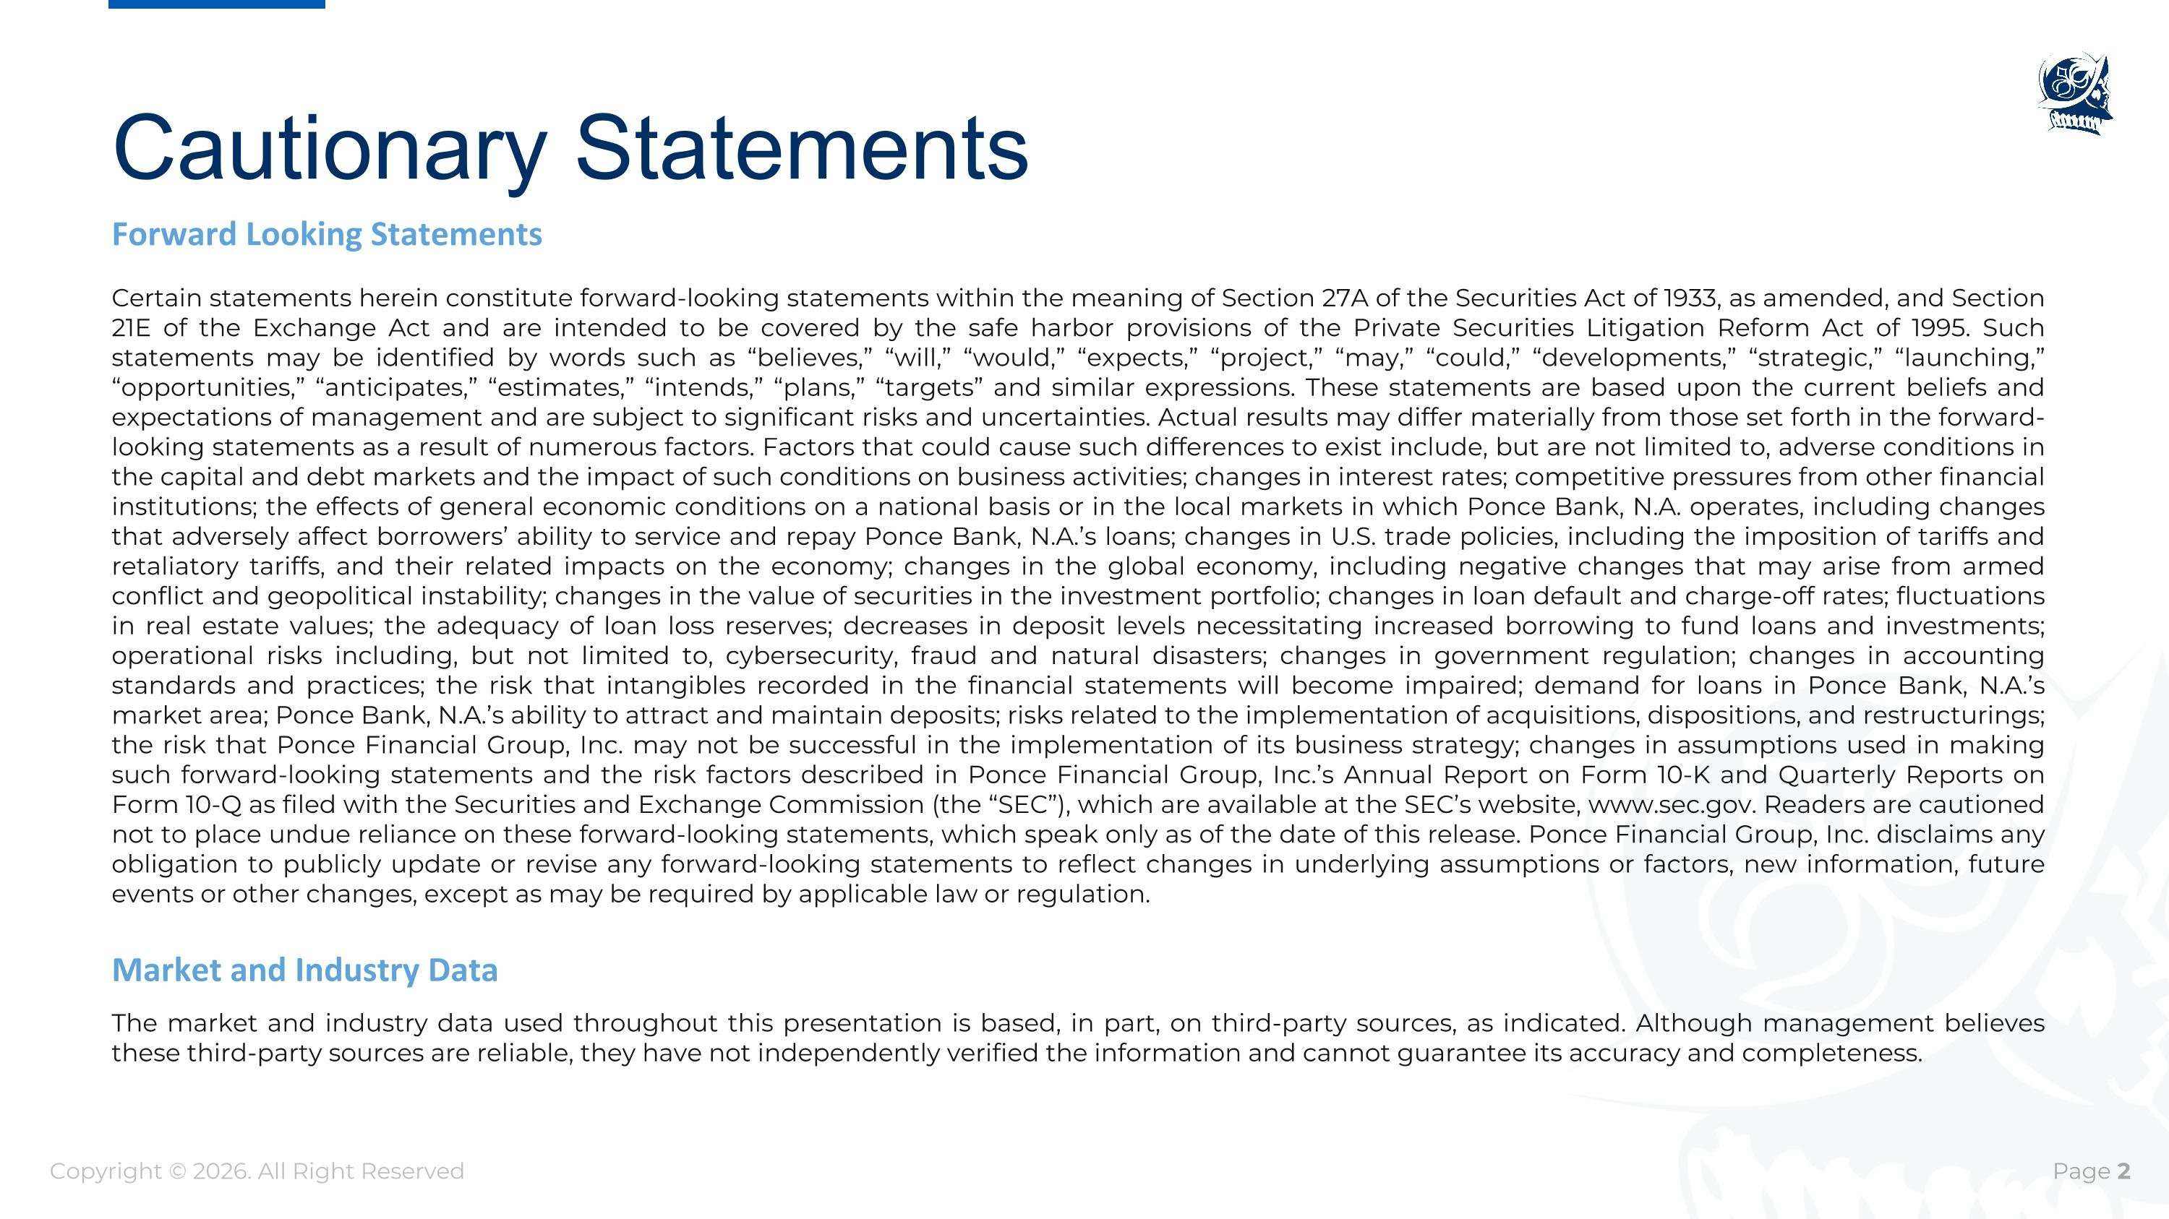
Cautionary Statements Certain statements herein constitute forward-looking statements within the meaning of Section 27A of the Securities Act of 1933, as amended, and Section 21E of the Exchange Act and are intended to be covered by the safe harbor provisions of the Private Securities Litigation Reform Act of 1995. Such statements may be identified by words such as “believes,” “will,” “would,” “expects,” “project,” “may,” “could,” “developments,” “strategic,” “launching,” “opportunities,” “anticipates,” “estimates,” “intends,” “plans,” “targets” and similar expressions. These statements are based upon the current beliefs and expectations of management and are subject to significant risks and uncertainties. Actual results may differ materially from those set forth in the forward-looking statements as a result of numerous factors. Factors that could cause such differences to exist include, but are not limited to, adverse conditions in the capital and debt markets and the impact of such conditions on business activities; changes in interest rates; competitive pressures from other financial institutions; the effects of general economic conditions on a national basis or in the local markets in which Ponce Bank, N.A. operates, including changes that adversely affect borrowers’ ability to service and repay Ponce Bank, N.A.’s loans; changes in U.S. trade policies, including the imposition of tariffs and retaliatory tariffs, and their related impacts on the economy; changes in the global economy, including negative changes that may arise from armed conflict and geopolitical instability; changes in the value of securities in the investment portfolio; changes in loan default and charge-off rates; fluctuations in real estate values; the adequacy of loan loss reserves; decreases in deposit levels necessitating increased borrowing to fund loans and investments; operational risks including, but not limited to, cybersecurity, fraud and natural disasters; changes in government regulation; changes in accounting standards and practices; the risk that intangibles recorded in the financial statements will become impaired; demand for loans in Ponce Bank, N.A.’s market area; Ponce Bank, N.A.’s ability to attract and maintain deposits; risks related to the implementation of acquisitions, dispositions, and restructurings; the risk that Ponce Financial Group, Inc. may not be successful in the implementation of its business strategy; changes in assumptions used in making such forward-looking statements and the risk factors described in Ponce Financial Group, Inc.’s Annual Report on Form 10-K and Quarterly Reports on Form 10-Q as filed with the Securities and Exchange Commission (the “SEC”), which are available at the SEC’s website, www.sec.gov. Readers are cautioned not to place undue reliance on these forward-looking statements, which speak only as of the date of this release. Ponce Financial Group, Inc. disclaims any obligation to publicly update or revise any forward-looking statements to reflect changes in underlying assumptions or factors, new information, future events or other changes, except as may be required by applicable law or regulation. Forward Looking Statements The market and industry data used throughout this presentation is based, in part, on third-party sources, as indicated. Although management believes these third-party sources are reliable, they have not independently verified the information and cannot guarantee its accuracy and completeness. Market and Industry Data Copyright © 2026. All Right Reserved

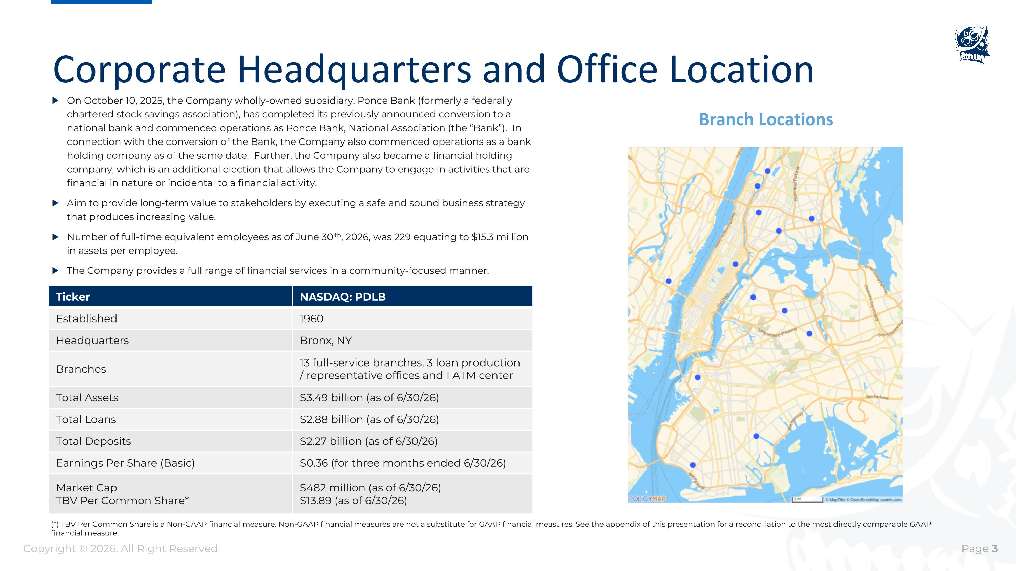
Corporate Headquarters and Office Location Branch Locations On October 10, 2025, the Company wholly-owned subsidiary, Ponce Bank (formerly a federally chartered stock savings association), has completed its previously announced conversion to a national bank and commenced operations as Ponce Bank, National Association (the “Bank”). In connection with the conversion of the Bank, the Company also commenced operations as a bank holding company as of the same date. Further, the Company also became a financial holding company, which is an additional election that allows the Company to engage in activities that are financial in nature or incidental to a financial activity. Aim to provide long-term value to stakeholders by executing a safe and sound business strategy that produces increasing value. Number of full-time equivalent employees as of June 30th, 2026, was 229 equating to $15.3 million in assets per employee. The Company provides a full range of financial services in a community-focused manner. Ticker NASDAQ: PDLB Established 1960 Headquarters Bronx, NY Branches 13 full-service branches, 3 loan production / representative offices and 1 ATM center Total Assets $3.49 billion (as of 6/30/26) Total Loans $2.88 billion (as of 6/30/26) Total Deposits $2.27 billion (as of 6/30/26) Earnings Per Share (Basic) $0.36 (for three months ended 6/30/26) Market Cap TBV Per Common Share* $482 million (as of 6/30/26) $13.89 (as of 6/30/26) Copyright © 2026. All Right Reserved (*) TBV Per Common Share is a Non-GAAP financial measure. Non-GAAP financial measures are not a substitute for GAAP financial measures. See the appendix of this presentation for a reconciliation to the most directly comparable GAAP financial measure.

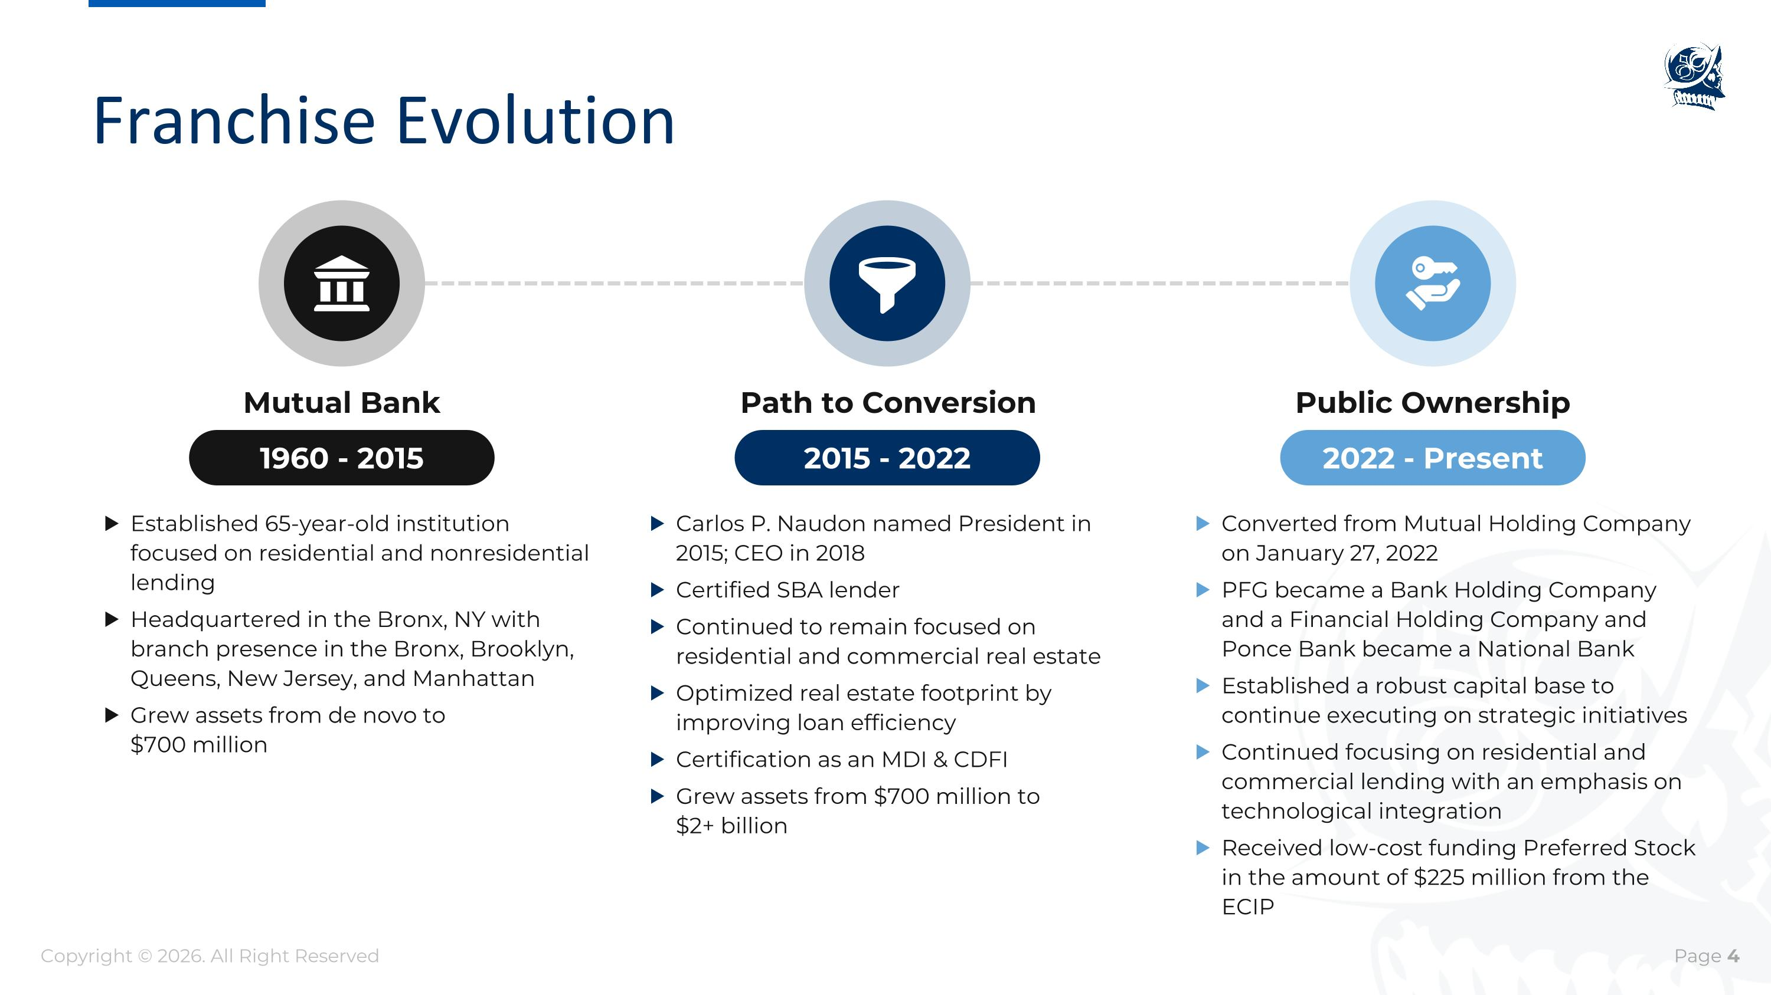
Franchise Evolution 2015 - 2022 Carlos P. Naudon named President in 2015; CEO in 2018 Certified SBA lender Continued to remain focused on residential and commercial real estate Optimized real estate footprint by improving loan efficiency Certification as an MDI & CDFI Grew assets from $700 million to ?$2+ billion Path to Conversion 2022 - Present Converted from Mutual Holding Company on January 27, 2022 PFG became a Bank Holding Company and a Financial Holding Company and Ponce Bank became a National Bank Established a robust capital base to continue executing on strategic initiatives Continued focusing on residential and commercial lending with an emphasis on technological integration Received low-cost funding Preferred Stock in the amount of $225 million from the ECIP Public Ownership 1960 - 2015 Established 65-year-old institution focused on residential and nonresidential lending Headquartered in the Bronx, NY with branch presence in the Bronx, Brooklyn, Queens, New Jersey, and Manhattan Grew assets from de novo to ?$700 million Mutual Bank Copyright © 2026. All Right Reserved


PFG Executive Management Executive Chairman?of the Board Steven A. Tsavaris Executive Vice President and Chief Lending Officer Ioannis Kouzilos Madeline V. Marquez President and Chief Executive Officer Carlos P. Naudon Executive Vice President and Chief Financial Officer Sergio J. Vaccaro Executive Vice President and Chief Operating Officer Luis G. Gonzalez Jr. Copyright © 2026. All Right Reserved 50+ years of experience Former President and CEO of Ponce De Leon Federal Savings Bank Former Chairman and CEO of PDLB Community Bancorp 15+ years of experience Former VP of Credit Administration Experienced at various financial institutions 50+ years of experience Retired Attorney and CPA Former Acting CEO and Director of Open Solutions, Inc., a fintech public company 25+ years of experience Former CFO of Private Bank Americas at HSBC Former US Head of FP&A at HSBC Former CFO of Home Loans at Morgan Stanley 17+ years of experience Former Bank Examiner Former Acting Assistant Deputy Comptroller, OCC Executive Vice President and Chief External Affairs Officer Executive Vice President and Chief Human Resources Officer Melissa DeLeon 15+ years of experience Former SVP of Human Resources Driver of people strategy Led culture transformation Retail banking operations expertise Executive Vice President and Chief Banking Officer Betty Campiz 15+ years of experience Former SVP of Digital Banking Led Ponce’s digital transformation (Salesforce, nCino) Extensive retail banking and CX expertise 25+ years of experience Former SVP of SBA & CDFI Initiatives Former Vice President at Business Initiative Corporation of New York Former Managing Director at Brooklyn Economic Development Corp.

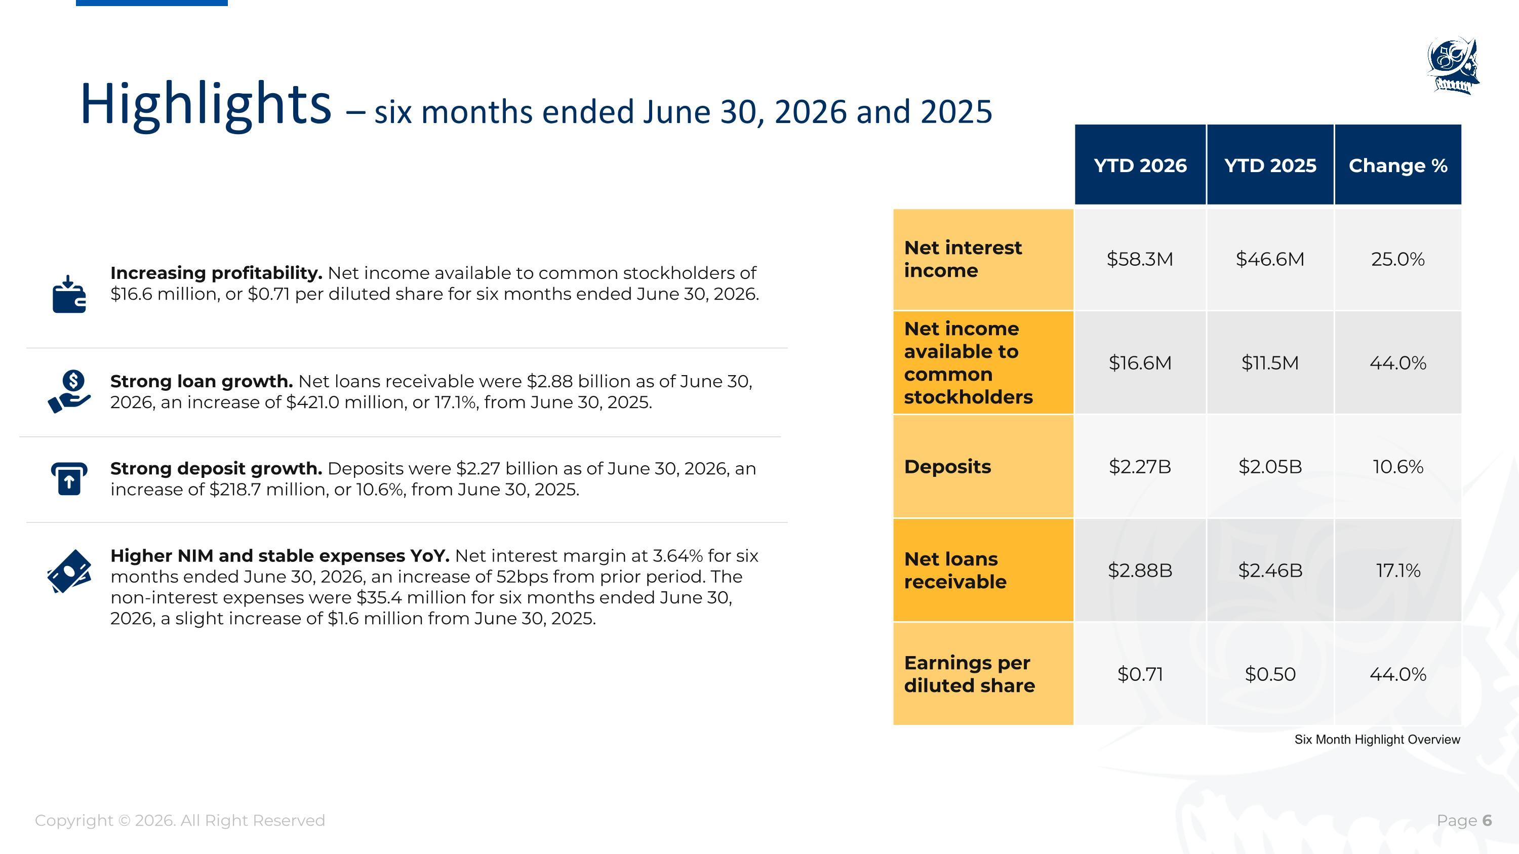
Highlights – six months ended June 30, 2026 and 2025 Strong loan growth. Net loans receivable were $2.88 billion as of June 30, 2026, an increase of $421.0 million, or 17.1%, from June 30, 2025. Higher NIM and stable expenses YoY. Net interest margin at 3.64% for six months ended June 30, 2026, an increase of 52bps from prior period. The non-interest expenses were $35.4 million for six months ended June 30, 2026, a slight increase of $1.6 million from June 30, 2025. Strong deposit growth. Deposits were $2.27 billion as of June 30, 2026, an increase of $218.7 million, or 10.6%, from June 30, 2025. Increasing profitability. Net income available to common stockholders of $16.6 million, or $0.71 per diluted share for six months ended June 30, 2026. Copyright © 2026. All Right Reserved Six Month Highlight Overview YTD 2026 YTD 2025 Change % Net interest ?income $58.3M $46.6M 25.0% Net income available to common stockholders $16.6M $11.5M 44.0% Deposits $2.27B $2.05B 10.6% Net loans receivable $2.88B $2.46B 17.1% Earnings per diluted share $0.71 $0.50 44.0%

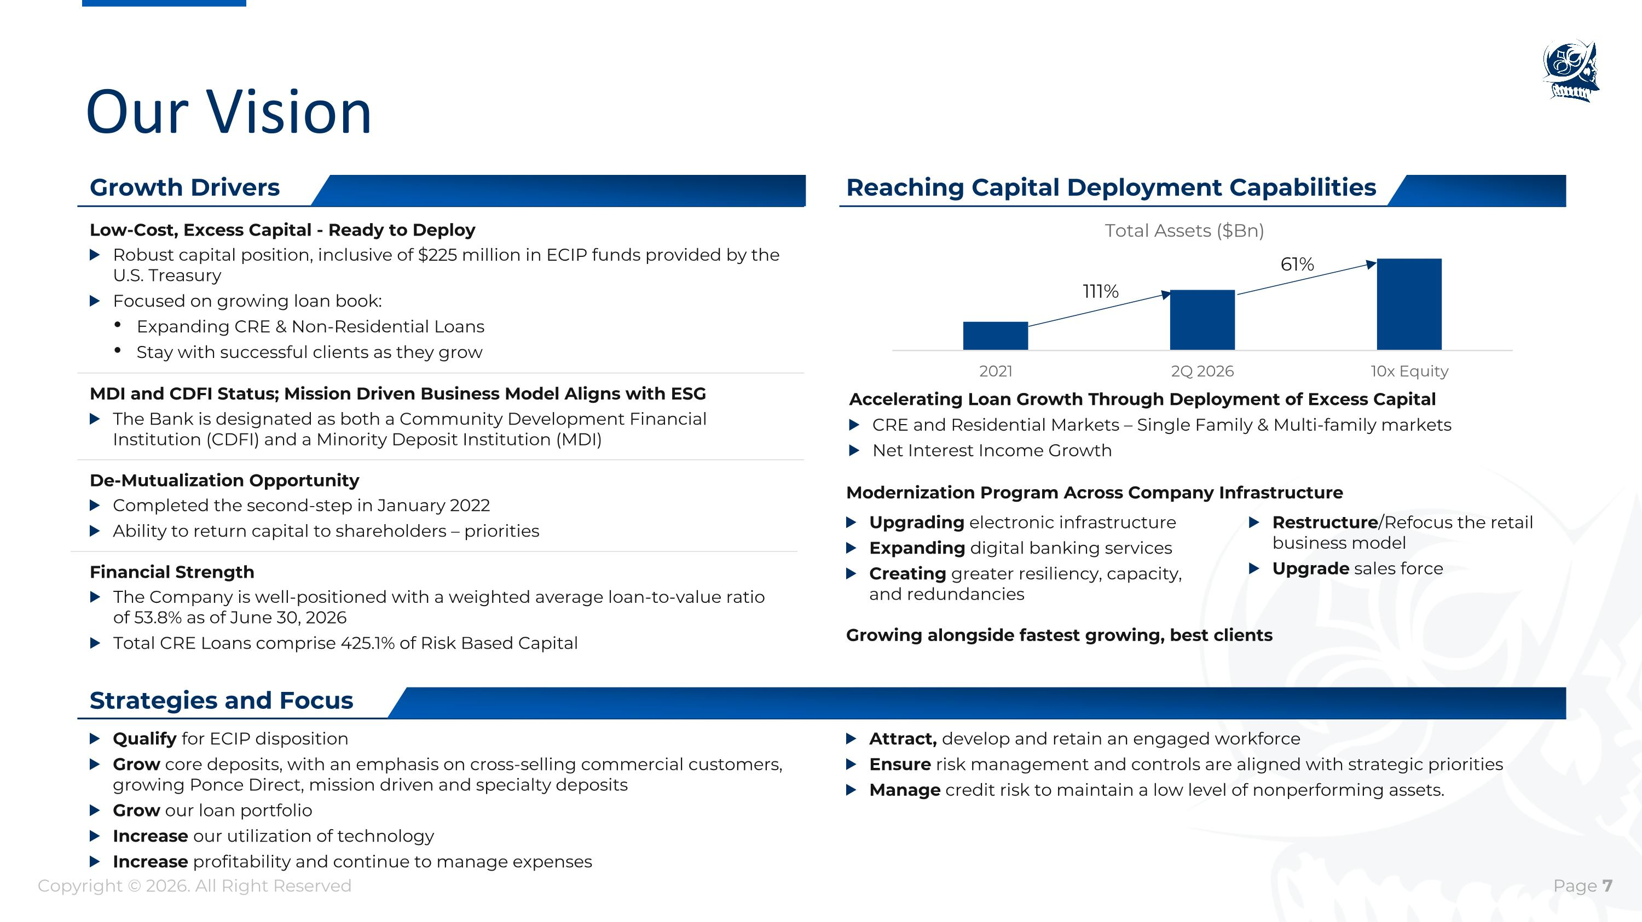
Our Vision Growing alongside fastest growing, best clients Reaching Capital Deployment Capabilities Qualify for ECIP disposition Grow core deposits, with an emphasis on cross-selling commercial customers, growing Ponce Direct, mission driven and specialty deposits Grow our loan portfolio Increase our utilization of technology Increase profitability and continue to manage expenses Robust capital position, inclusive of $225 million in ECIP funds provided by the U.S. Treasury Focused on growing loan book: Expanding CRE & Non-Residential Loans Stay with successful clients as they grow Low-Cost, Excess Capital - Ready to Deploy The Bank is designated as both a Community Development Financial Institution (CDFI) and a Minority Deposit Institution (MDI) MDI and CDFI Status; Mission Driven Business Model Aligns with ESG Completed the second-step in January 2022 Ability to return capital to shareholders – priorities De-Mutualization Opportunity The Company is well-positioned with a weighted average loan-to-value ratio of 53.8% as of June 30, 2026 Total CRE Loans comprise 425.1% of Risk Based Capital Financial Strength Strategies and Focus Growth Drivers Accelerating Loan Growth Through Deployment of Excess Capital CRE and Residential Markets – Single Family & Multi-family markets Net Interest Income Growth Upgrading electronic infrastructure Expanding digital banking services Creating greater resiliency, capacity, and redundancies Modernization Program Across Company Infrastructure Restructure/Refocus the retail business model Upgrade sales force Attract, develop and retain an engaged workforce Ensure risk management and controls are aligned with strategic priorities Manage credit risk to maintain a low level of nonperforming assets. Copyright © 2026. All Right Reserved 61% 111%

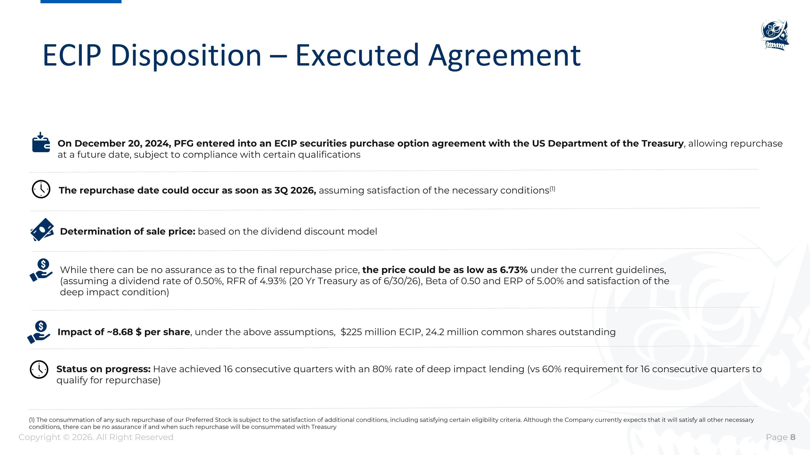
ECIP Disposition – Executed Agreement On December 20, 2024, PFG entered into an ECIP securities purchase option agreement with the US Department of the Treasury, allowing repurchase at a future date, subject to compliance with certain qualifications Determination of sale price: based on the dividend discount model While there can be no assurance as to the final repurchase price, the price could be as low as 6.73% under the current guidelines, (assuming a dividend rate of 0.50%, RFR of 4.93% (20 Yr Treasury as of 6/30/26), Beta of 0.50 and ERP of 5.00% and satisfaction of the deep impact condition) Impact of ~8.68 $ per share, under the above assumptions, $225 million ECIP, 24.2 million common shares outstanding The repurchase date could occur as soon as 3Q 2026, assuming satisfaction of the necessary conditions(1) Status on progress: Have achieved 16 consecutive quarters with an 80% rate of deep impact lending (vs 60% requirement for 16 consecutive quarters to qualify for repurchase) Copyright © 2026. All Right Reserved (1) The consummation of any such repurchase of our Preferred Stock is subject to the satisfaction of additional conditions, including satisfying certain eligibility criteria. Although the Company currently expects that it will satisfy all other necessary conditions, there can be no assurance if and when such repurchase will be consummated with Treasury

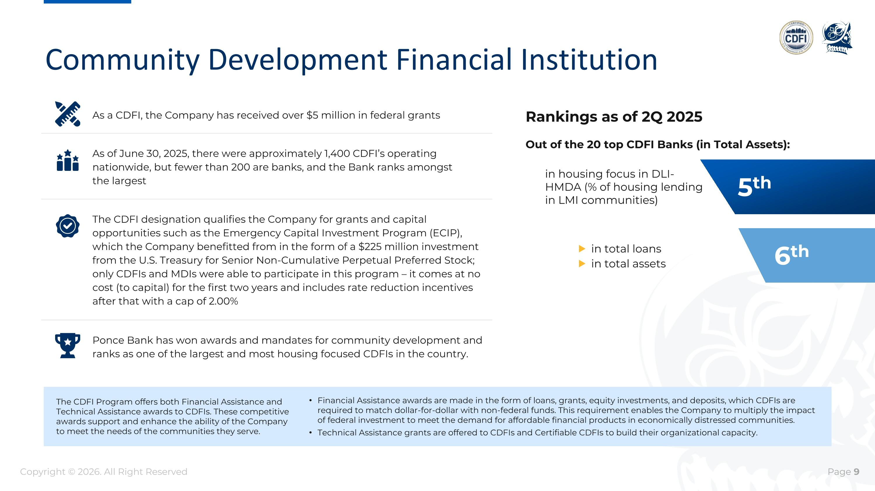
Community Development Financial Institution The CDFI Program offers both Financial Assistance and Technical Assistance awards to CDFIs. These competitive awards support and enhance the ability of the Company to meet the needs of the communities they serve. Financial Assistance awards are made in the form of loans, grants, equity investments, and deposits, which CDFIs are required to match dollar-for-dollar with non-federal funds. This requirement enables the Company to multiply the impact of federal investment to meet the demand for affordable financial products in economically distressed communities. Technical Assistance grants are offered to CDFIs and Certifiable CDFIs to build their organizational capacity. Out of the 20 top CDFI Banks (in Total Assets): in housing focus in DLI-HMDA (% of housing lending in LMI communities) in total loans in total assets As a CDFI, the Company has received over $5 million in federal grants As of June 30, 2025, there were approximately 1,400 CDFI’s operating nationwide, but fewer than 200 are banks, and the Bank ranks amongst ?the largest The CDFI designation qualifies the Company for grants and capital opportunities such as the Emergency Capital Investment Program (ECIP), which the Company benefitted from in the form of a $225 million investment from the U.S. Treasury for Senior Non-Cumulative Perpetual Preferred Stock; only CDFIs and MDIs were able to participate in this program – it comes at no cost (to capital) for the first two years and includes rate reduction incentives after that with a cap of 2.00% Ponce Bank has won awards and mandates for community development and ranks as one of the largest and most housing focused CDFIs in the country. Rankings as of 2Q 2025 5th 6th Copyright © 2026. All Right Reserved

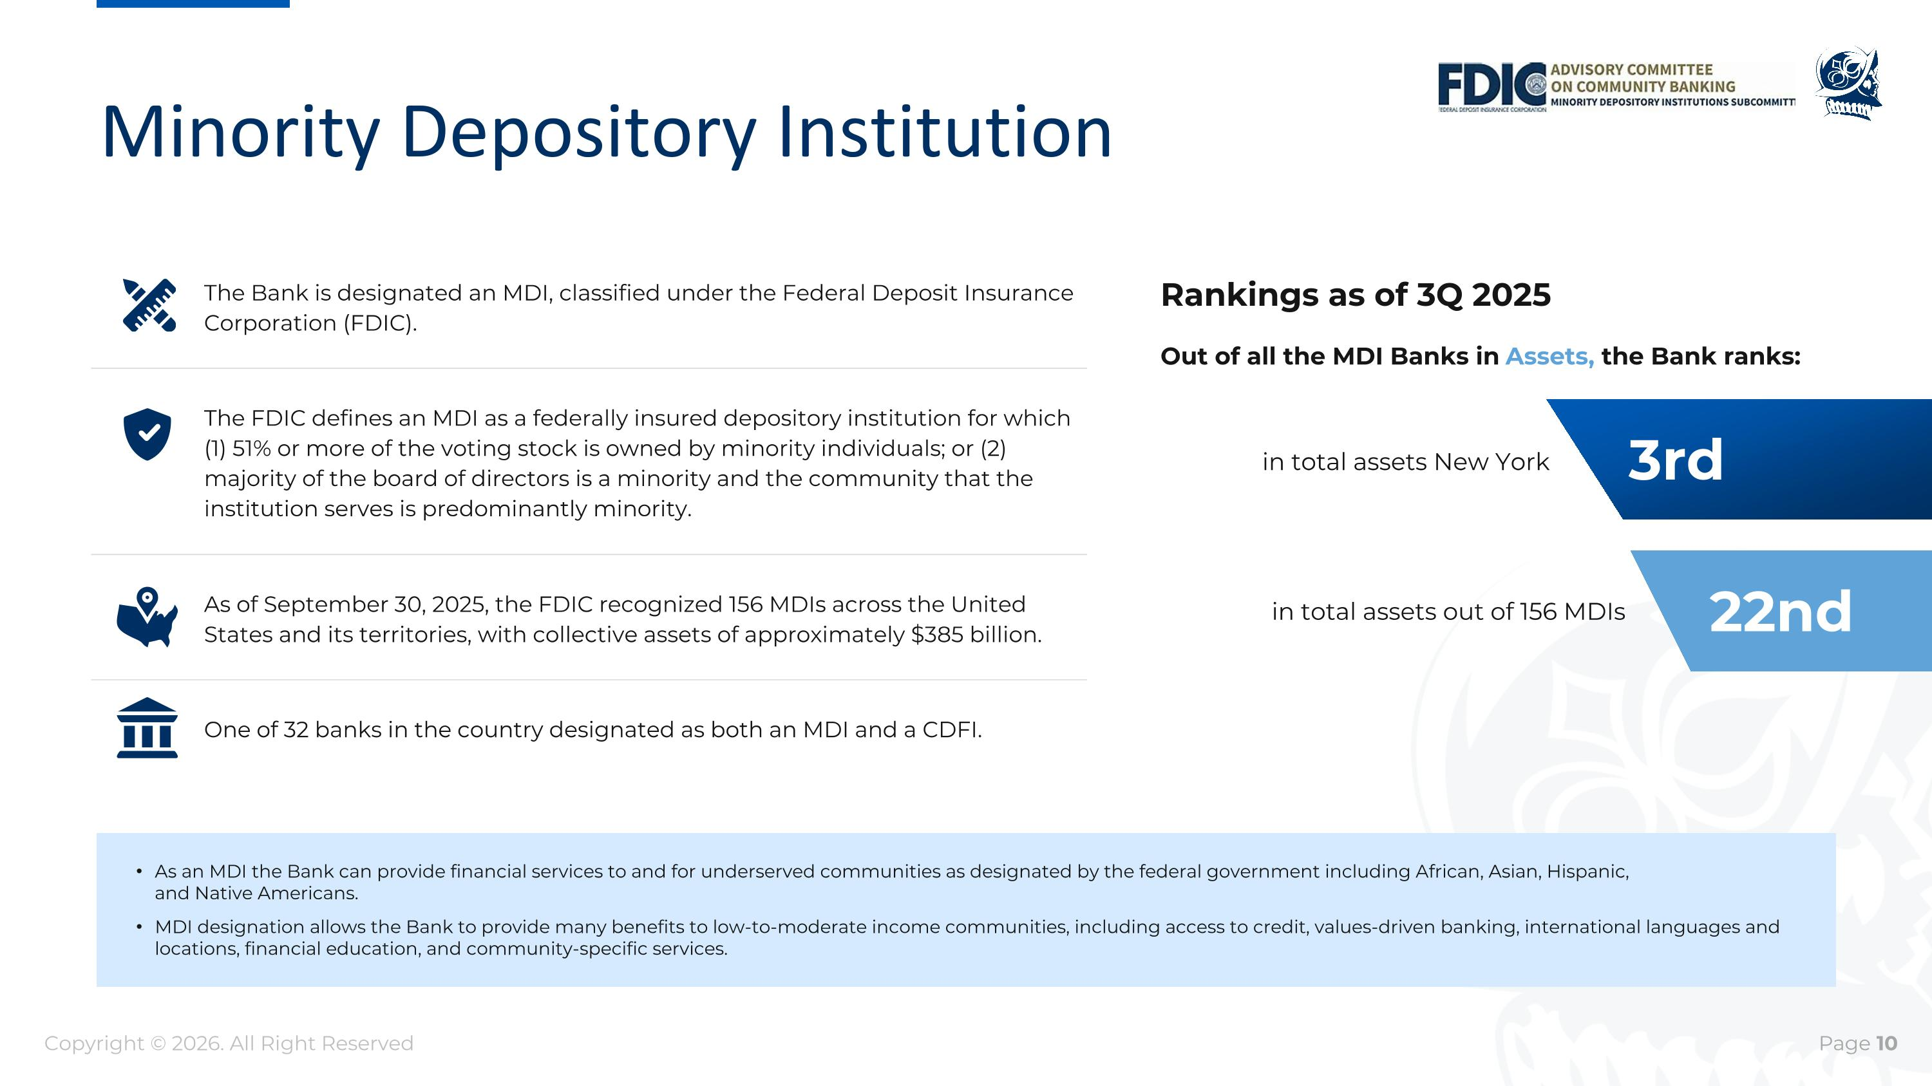
Minority Depository Institution One of 32 banks in the country designated as both an MDI and a CDFI. As of September 30, 2025, the FDIC recognized 156 MDIs across the United States and its territories, with collective assets of approximately $385 billion. As an MDI the Bank can provide financial services to and for underserved communities as designated by the federal government including African, Asian, Hispanic, ?and Native Americans. MDI designation allows the Bank to provide many benefits to low-to-moderate income communities, including access to credit, values-driven banking, international languages and locations, financial education, and community-specific services. Out of all the MDI Banks in Assets, the Bank ranks: Rankings as of 3Q 2025 The Bank is designated an MDI, classified under the Federal Deposit Insurance Corporation (FDIC). The FDIC defines an MDI as a federally insured depository institution for which (1) 51% or more of the voting stock is owned by minority individuals; or (2) majority of the board of directors is a minority and the community that the institution serves is predominantly minority. in total assets New York in total assets out of 156 MDIs 3rd 22nd Copyright © 2026. All Right Reserved


Appendix

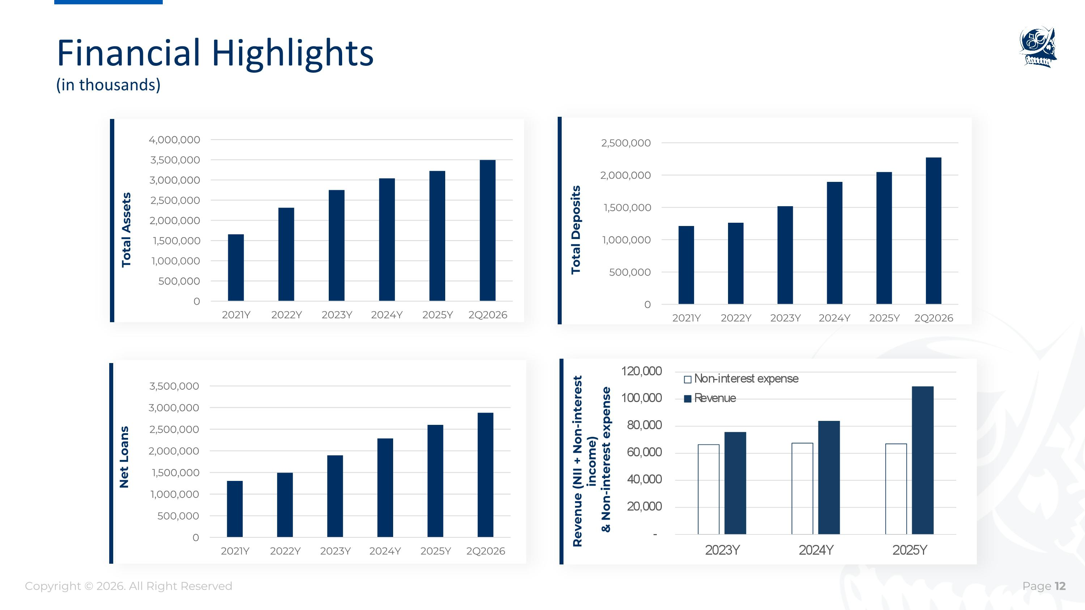
Total Assets Total Deposits Financial Highlights (in thousands) Net Loans Revenue (NII + Non-interest income) & Non-interest expense Copyright © 2026. All Right Reserved

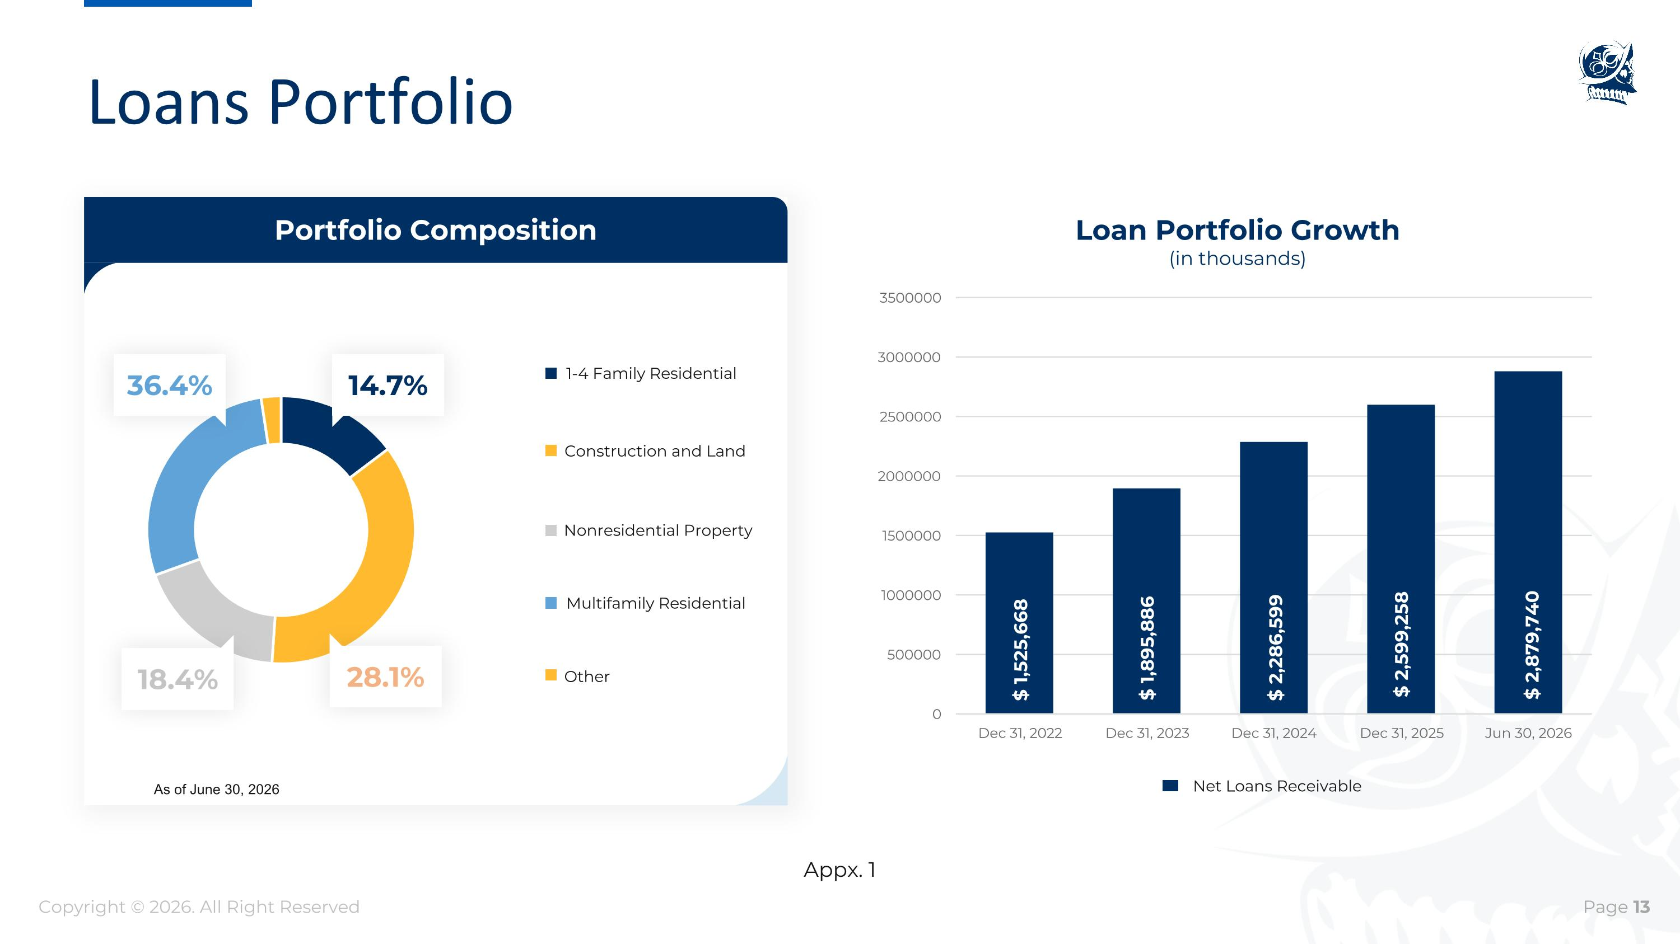
Appx. 1 Portfolio Composition 14.7% 28.1% 18.4% 36.4% 1-4 Family Residential Construction and Land Multifamily Residential Nonresidential Property $ 2,286,599 $ 2,599,258 $ 2,879,740 $ 1,525,668 $ 1,895,886 Loan Portfolio Growth (in thousands) Net Loans Receivable Loans Portfolio As of June 30, 2026 Other Copyright © 2026. All Right Reserved

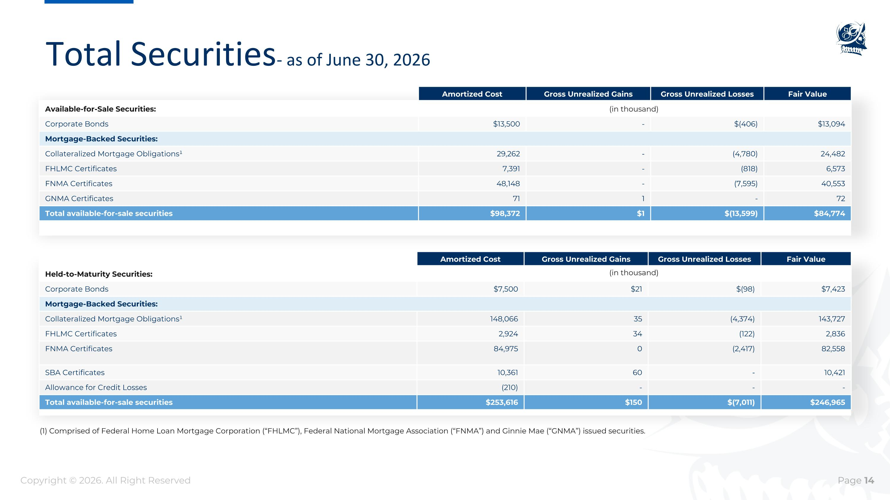
Total Securities - as of June 30, 2026 Amortized Cost Gross Unrealized Gains Gross Unrealized Losses Fair Value Available-for-Sale Securities: Corporate Bonds $13,500 - $(406) $13,094 Mortgage-Backed Securities: Collateralized Mortgage Obligations¹ 29,262 - (4,780) 24,482 FHLMC Certificates 7,391 - (818) 6,573 FNMA Certificates 48,148 - (7,595) 40,553 GNMA Certificates 71 1 - 72 Total available-for-sale securities $98,372 $1 $(13,599) $84,774 Amortized Cost Gross Unrealized Gains Gross Unrealized Losses Fair Value Held-to-Maturity Securities: Corporate Bonds $7,500 $21 $(98) $7,423 Mortgage-Backed Securities: Collateralized Mortgage Obligations¹ 148,066 35 (4,374) 143,727 FHLMC Certificates 2,924 34 (122) 2,836 FNMA Certificates 84,975 0 (2,417) 82,558 SBA Certificates 10,361 60 - 10,421 Allowance for Credit Losses (210) - - - Total available-for-sale securities $253,616 $150 $(7,011) $246,965 (1) Comprised of Federal Home Loan Mortgage Corporation (“FHLMC”), Federal National Mortgage Association (“FNMA”) and Ginnie Mae (“GNMA”) issued securities. (in thousand) (in thousand) Copyright © 2026. All Right Reserved

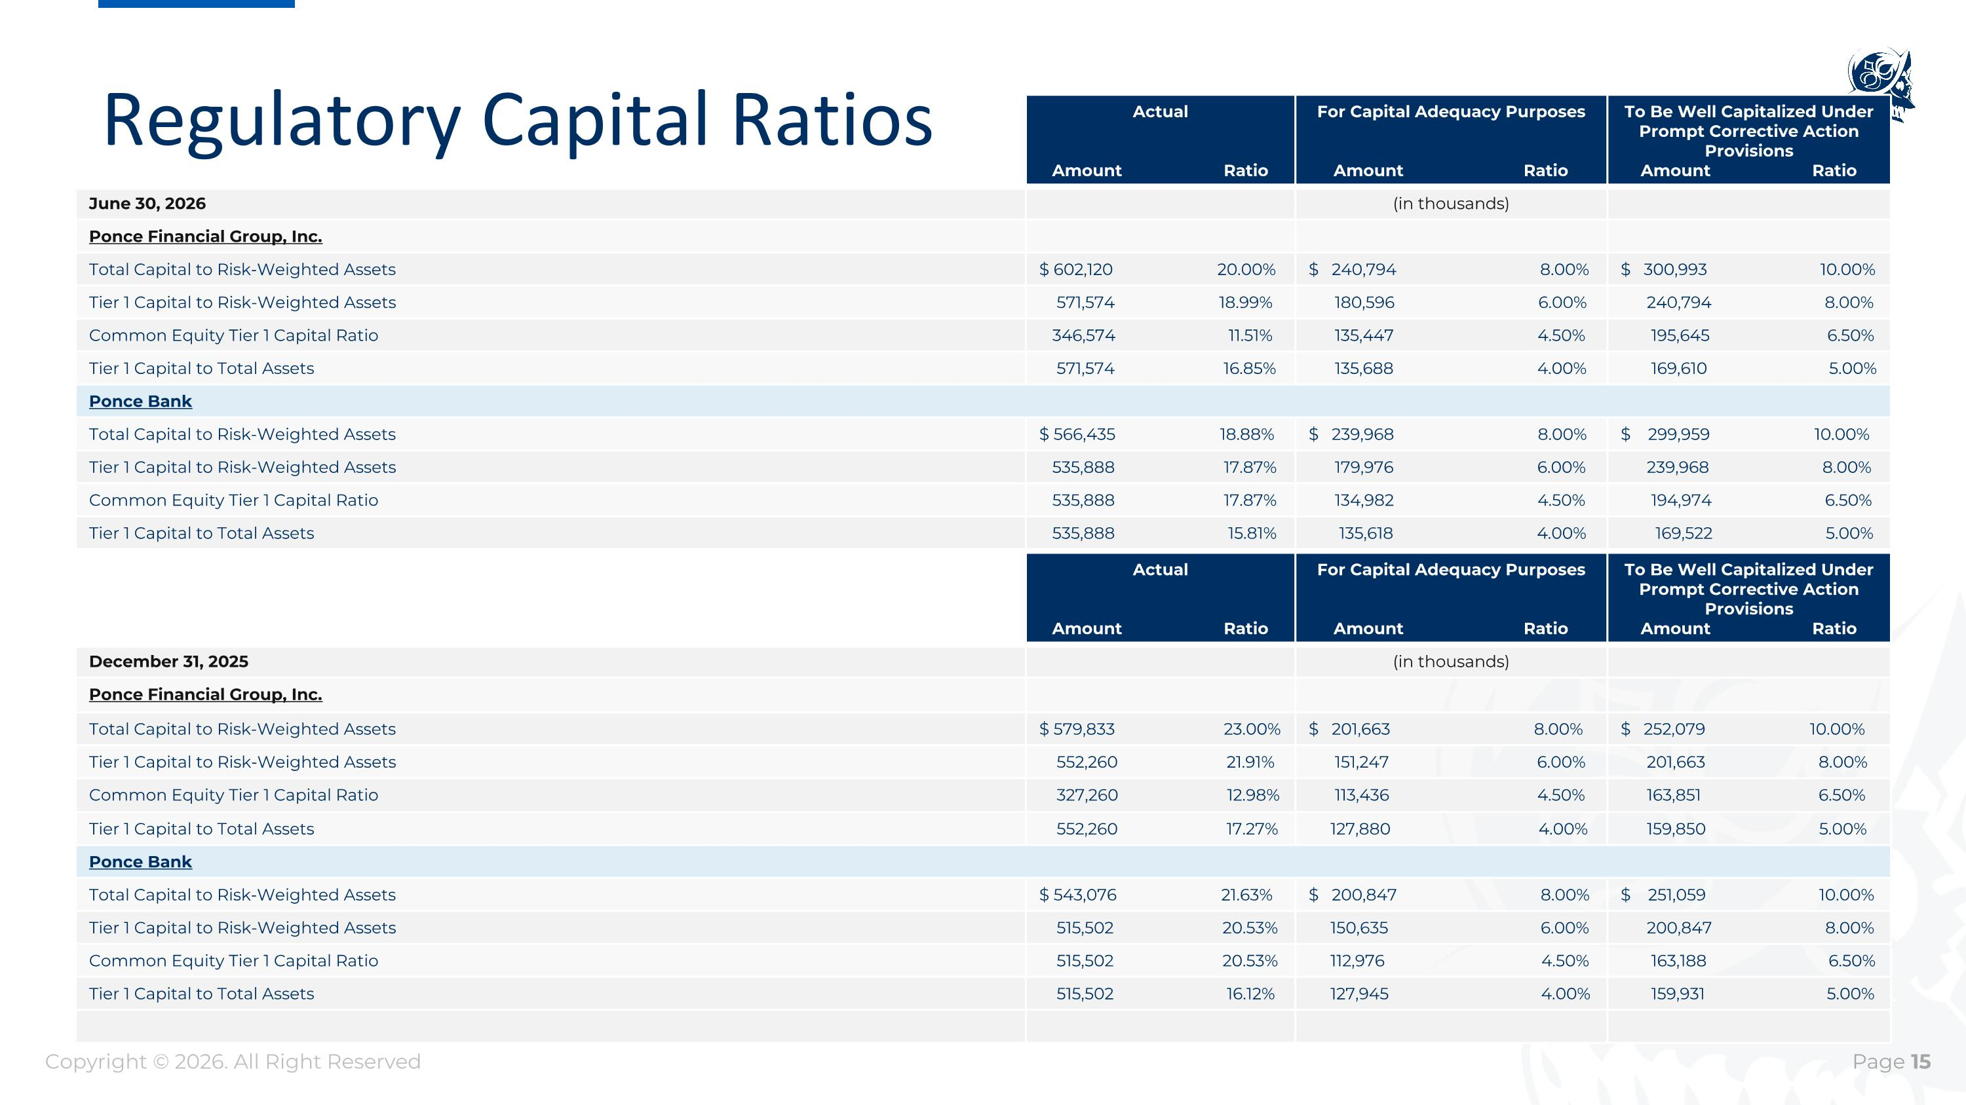
Actual Amount Ratio For Capital Adequacy Purposes Amount Ratio To Be Well Capitalized Under Prompt Corrective Action Provisions Amount Ratio December 31, 2025 (in thousands) Ponce Financial Group, Inc. Total Capital to Risk-Weighted Assets $ 579,833 23.00% $ 201,663 8.00% $ 252,079 10.00% Tier 1 Capital to Risk-Weighted Assets 552,260 21.91% 151,247 6.00% 201,663 8.00% Common Equity Tier 1 Capital Ratio 327,260 12.98% 113,436 4.50% 163,851 6.50% Tier 1 Capital to Total Assets 552,260 17.27% 127,880 4.00% 159,850 5.00% Ponce Bank Total Capital to Risk-Weighted Assets $ 543,076 21.63% $ 200,847 8.00% $ 251,059 10.00% Tier 1 Capital to Risk-Weighted Assets 515,502 20.53% 150,635 6.00% 200,847 8.00% Common Equity Tier 1 Capital Ratio 515,502 20.53% 112,976 4.50% 163,188 6.50% Tier 1 Capital to Total Assets 515,502 16.12% 127,945 4.00% 159,931 5.00% Actual Amount Ratio For Capital Adequacy Purposes Amount Ratio To Be Well Capitalized Under Prompt Corrective Action Provisions Amount Ratio June 30, 2026 (in thousands) Ponce Financial Group, Inc. Total Capital to Risk-Weighted Assets $ 602,120 20.00% $ 240,794 8.00% $ 300,993 10.00% Tier 1 Capital to Risk-Weighted Assets 571,574 18.99% 180,596 6.00% 240,794 8.00% Common Equity Tier 1 Capital Ratio 346,574 11.51% 135,447 4.50% 195,645 6.50% Tier 1 Capital to Total Assets 571,574 16.85% 135,688 4.00% 169,610 5.00% Ponce Bank Total Capital to Risk-Weighted Assets $ 566,435 18.88% $ 239,968 8.00% $ 299,959 10.00% Tier 1 Capital to Risk-Weighted Assets 535,888 17.87% 179,976 6.00% 239,968 8.00% Common Equity Tier 1 Capital Ratio 535,888 17.87% 134,982 4.50% 194,974 6.50% Tier 1 Capital to Total Assets 535,888 15.81% 135,618 4.00% 169,522 5.00% Regulatory Capital Ratios Copyright © 2026. All Right Reserved

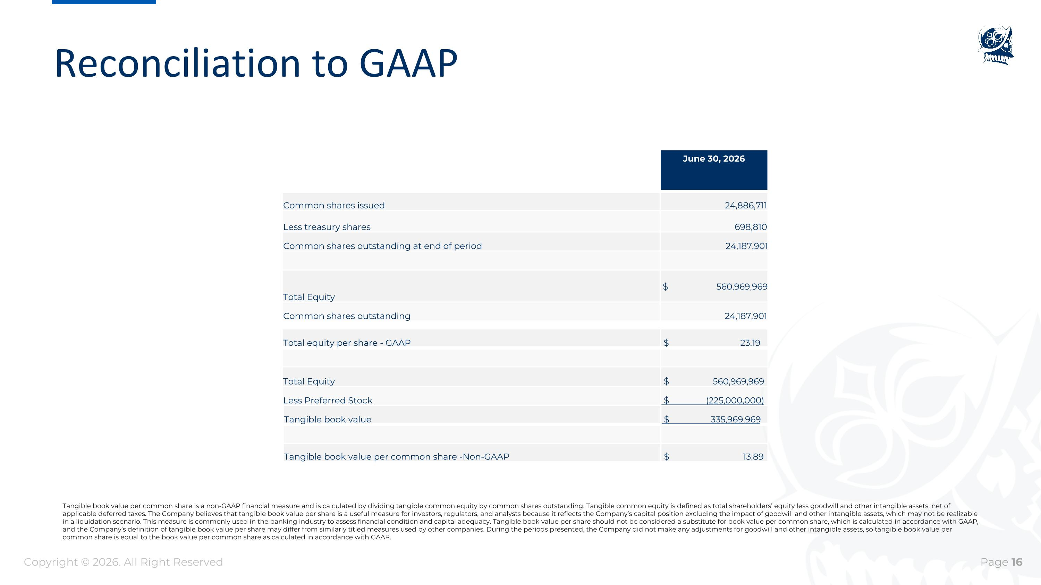
Reconciliation to GAAP June 30, 2026 Common shares issued 24,886,711 Less treasury shares 698,810 Common shares outstanding at end of period 24,187,901 Total Equity $ 560,969,969 Common shares outstanding 24,187,901 Total equity per share - GAAP $ 23.19 Total Equity $ 560,969,969 Less Preferred Stock $ (225,000,000) Tangible book value $ 335,969,969 Tangible book value per common share -Non-GAAP $ 13.89 Copyright © 2026. All Right Reserved Tangible book value per common share is a non-GAAP financial measure and is calculated by dividing tangible common equity by common shares outstanding. Tangible common equity is defined as total shareholders’ equity less goodwill and other intangible assets, net of applicable deferred taxes. The Company believes that tangible book value per share is a useful measure for investors, regulators, and analysts because it reflects the Company’s capital position excluding the impact of goodwill and other intangible assets, which may not be realizable in a liquidation scenario. This measure is commonly used in the banking industry to assess financial condition and capital adequacy. Tangible book value per share should not be considered a substitute for book value per common share, which is calculated in accordance with GAAP, and the Company’s definition of tangible book value per share may differ from similarly titled measures used by other companies. During the periods presented, the Company did not make any adjustments for goodwill and other intangible assets, so tangible book value per common share is equal to the book value per common share as calculated in accordance with GAAP.

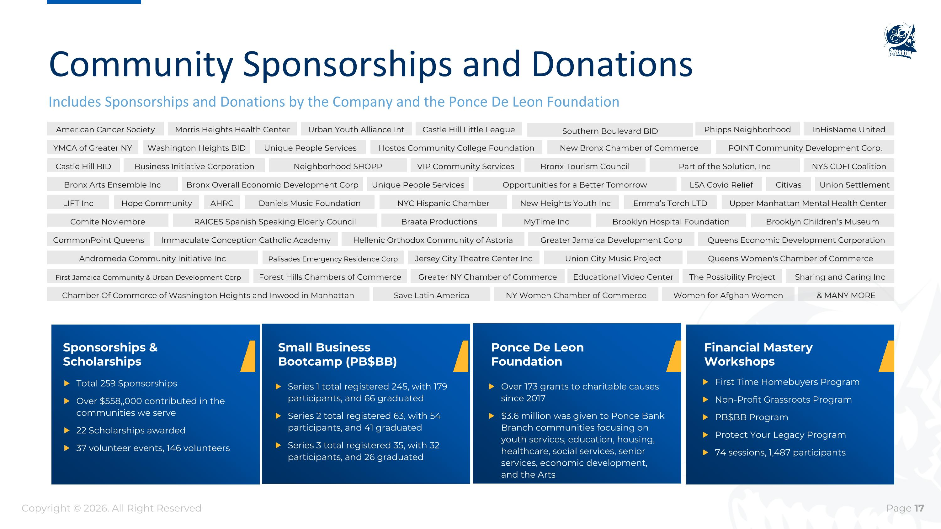
Community Sponsorships and Donations Includes Sponsorships and Donations by the Company and the Ponce De Leon Foundation Sponsorships & Scholarships Small Business ?Bootcamp (PB$BB) Over 173 grants to charitable causes since 2017 $3.6 million was given to Ponce Bank Branch communities focusing on youth services, education, housing, healthcare, social services, senior services, economic development, and the Arts Ponce De Leon Foundation Financial Mastery Workshops American Cancer Society Morris Heights Health Center Urban Youth Alliance Int Castle Hill Little League Southern Boulevard BID Phipps Neighborhood InHisName United YMCA of Greater NY Washington Heights BID Unique People Services Hostos Community College Foundation New Bronx Chamber of Commerce POINT Community Development Corp. Castle Hill BID Business Initiative Corporation Neighborhood SHOPP VIP Community Services Bronx Tourism Council NYS CDFI Coalition Part of the Solution, Inc Bronx Arts Ensemble Inc Bronx Overall Economic Development Corp Unique People Services Opportunities for a Better Tomorrow Union Settlement LSA Covid Relief Citivas LIFT Inc Hope Community AHRC Daniels Music Foundation NYC Hispanic Chamber Upper Manhattan Mental Health Center New Heights Youth Inc Emma’s Torch LTD Comite Noviembre RAICES Spanish Speaking Elderly Council Braata Productions MyTime Inc Brooklyn Hospital Foundation Brooklyn Children’s Museum CommonPoint Queens Immaculate Conception Catholic Academy Hellenic Orthodox Community of Astoria Greater Jamaica Development Corp Queens Economic Development Corporation Andromeda Community Initiative Inc Palisades Emergency Residence Corp Jersey City Theatre Center Inc Queens Women's Chamber of Commerce Union City Music Project First Jamaica Community & Urban Development Corp Forest Hills Chambers of Commerce Greater NY Chamber of Commerce Sharing and Caring Inc Educational Video Center The Possibility Project Chamber Of Commerce of Washington Heights and Inwood in Manhattan & MANY MORE Save Latin America NY Women Chamber of Commerce Women for Afghan Women Copyright © 2026. All Right Reserved Total 259 Sponsorships Over $558,,000 contributed in the communities we serve 22 Scholarships awarded 37 volunteer events, 146 volunteers Series 1 total registered 245, with 179 participants, and 66 graduated Series 2 total registered 63, with 54 participants, and 41 graduated Series 3 total registered 35, with 32 participants, and 26 graduated First Time Homebuyers Program Non-Profit Grassroots Program PB$BB Program Protect Your Legacy Program 74 sessions, 1,487 participants


NASDAQ: PDLB Thank you.

